A
Industrial Project Report
(Project Semester Jan-June 2026)
VaultScan
GitHub Repository Secret Detection System

Submitted in for the partial fulfilment of the degree of Bachelors of Computer Application (BCA)

By
Muskan Rathore
Student Regn. No. 23BCAN0515



Submitted to:

Faculty Internship Guide Industry Guide
Name: Mr. Kaushal Sharma Name: Mr. Akash Gaur
Designation: Assistant Professor Designation: Tech-Lead

School of Computer Applications

JECRC UNIVERSITY, JAIPUR
July 2026

Declaration

I hereby declare that the project work entitled “VaultScan GitHub Repository Secret Detection System” is an authentic record of my own work carried out at “Upflairs Pvt. Ltd., Jaipur” as requirements of six months industrial project for the award of degree of “BCA”, from JECRC University, under the guidance of “Mr. Akash Gaur” and “Mr. Kaushal Sharma”, during 10th Feb to 10th Aug, 2026.

Signature of student

Name of Student: Muskan Rathore
Student Regn. No. 23BCAN0515

Date: ___________________

It is certified that the above statement made by the student is correct to the best of our knowledge

Signature Signature

Faculty Internship Guide Industry Guide
Name: Mr. Kaushal Sharma Name: Mr. Akash Gaur
Designation: Assistant Professor Designation: Tech-Lead
Seal of Company

Preface

Industrial training plays a vital role in bridging the gap between academic learning and professional practice by providing students with practical exposure to real-world software development environments. It enables students to apply theoretical concepts acquired during their academic curriculum to industry-oriented projects while developing technical expertise, problem-solving abilities, teamwork, and professional ethics. The internship experience also familiarizes students with contemporary software development methodologies, tools, and best practices followed in the IT industry.

This report presents the work carried out during the six-month industrial internship at Upflairs Pvt. Ltd., Jaipur, undertaken as a partial fulfilment of the requirements for the award of the Bachelor of Computer Applications (BCA) degree from JECRC University. During the internship, extensive practical experience was gained in MERN Stack Development, including frontend development using React.js, backend development using Node.js and Express.js, database management using MongoDB, RESTful API development, authentication mechanisms, version control using Git, and collaborative software development practices.

The primary outcome of the internship was the design and development of VaultScan, a full-stack web application developed to identify and analyze exposed secrets in GitHub repositories.

This report documents the complete internship journey, including the organization overview, project objectives, problem definition, system analysis, design methodology, implementation, testing, results, and key learnings acquired throughout the internship. It also reflects the practical knowledge gained by working in an industry-oriented environment and demonstrates the successful application of software engineering principles to solve a real-world cybersecurity challenge.

It is hoped that this report provides a comprehensive understanding of the work accomplished during the internship and serves as evidence of the technical knowledge, practical skills, and professional experience acquired during this industrial training. The experience has significantly contributed to strengthening both technical competence and professional confidence, preparing for future challenges in the fields of software development, cybersecurity, and intelligent application development.
Internship Completion Certificate



Acknowledgements

I express my sincere gratitude to Upflairs Pvt. Ltd., Jaipur, for providing me with the opportunity to undertake my industrial internship in a professional and learning-oriented environment. The exposure to real-world software development and industry practices has significantly enhanced my technical knowledge and professional skills.

I would like to extend my heartfelt thanks to my Industry Guide, Mr. Akash Gaur (Tech Lead), for his constant guidance, valuable suggestions, and encouragement throughout the internship. His mentorship played a significant role in the successful completion of this project.

I am equally grateful to my Faculty Internship Guide, Mr. Kaushal Sharma, for his continuous support, motivation, and academic guidance during the internship period. I also thank the faculty members and the School of Computer Applications, JECRC University, for providing me with the knowledge and opportunities that made this internship possible.

Finally, I express my heartfelt gratitude to my parents, family, and friends for their unwavering support, encouragement, and motivation throughout this journey. Their constant belief in me has been a source of inspiration in successfully completing this internship and project.

INDEX
List of Illustrations 11
Abstract 12
Introduction 13
Background 13
Problem Statement 13
Need for the Project 14
Project Overview 15
Scope of the Project 16
Internship Context 16
Internship Organization Overview 18
Industry Mentor Profile 19
Internship Objectives 20
Roles and Responsibility 21
Position Overview 21
Responsibilities 21
Requirements 22
Technical Skills Gained 22
Project Undertaken 23
Literature Review (Technology Used) 23
Gap Identified 23
Proposed Solution 24
Comparative Analysis of Existing Tools 24
Technology Stack 25
React.js 25
Node.js 25
Express.js 25
MongoDB 25
Git & GitHub 26
GitHub API 26
Regular Expressions (Regex) 26
Shannon Entropy Algorithm 26
Vite (React) 26
Feasibility Study 28
Feasibility Analysis 28
Technical Feasibility 28
Economic Feasibility 28
Operational Feasibility 28
Schedule Feasibility 29
Development Methodology 29
Software Development Life Cycle (SDLC) 31
Risk and Constraints Analysis 32
Risks and Constraints: 33
User Interaction and Process Analysis 33
Problem and Solution Analysis 34
Project Planning and Execution 35
Decision Analysis and Technology Selection 36
System Analysis 38
Introduction to System Analysis 38
Existing System 38
Limitations 38
Proposed System 39
Requirement Elicitation 40
Input–Process–Output (IPO) Analysis 42
Functional Requirement Analysis: 43
User Authentication and Authorization 43
Repository Scanning Functionality 43
Secret Detection Mechanism 44
Risk Classification and Categorization 44
Data Storage and Management 44
Dashboard Visualization 44
Historical Tracking and Analytics 45
Admin Control and Monitoring 45
Error Handling and Validation 45
Non-Functional Requirement Analysis: 45
Performance 46
Scalability 46
Security 46
Reliability 47
Usability 47
Maintainability 47
Availability 47
Compatibility 47
Methodology 48
Methodology Overview 48
System Implementation Details 49
System Architecture 49
Data Flow Diagram (DFD) 51
Entity Relationship Diagram (ERD) 52
Modules of the System 53
Modules of the System: 53
Authentication Module 54
Scanner Module 54
Features of Scanner Module: 55
API Design 55
API Categories 56
Authentication and Authorization Design 57
Scanner Engine Design 57
Data Processing and Transformation Design 58
Frontend UI/UX Design Approach 59
Error Handling Design 60
Security Design Considerations 61
Performance Optimization Design 62
Scalability Design 63
Implementation 64
Technology Stack 64
Features Implemented 65
Scanner Implementation 65
Authentication Implementation 68
Frontend Implementation 68
Backend Implementation 69
Testing and Validation 70
Testing Strategy and Methodology 71
Testing Environment and Tools 71
Test Planning 72
Test Result Evaluation 73
Detailed Testing Analysis 74
Accuracy Analysis of Scanner Engine 74
Performance Analysis 75
Security Testing Analysis 75
Usability Analysis 76
Stress and Reliability Analysis 77
Limitations Identified During Testing 77
Validation 78
Outcome of Project 79
Conclusion 84
Future Scope 85
Appendices 88
Appendix A: Sample Source Code 88
Appendix B: API Endpoints 88
Appendix C: Database Schema 88
Appendix D: System Screenshots 88
Appendix E: Project Repository 88
References and Bibliography 89

List of Illustrations

Figure 1 VaultScan - The Scanner App 39
Figure 2 User Auth Flow 43
Figure 3 System Architecture of VaultScan 50
Figure 4 Data Flow Diagram 51
Figure 5 Entity Relationship Diagram (ERD) of VaultScan 52
Figure 6 API Postman 56
Figure 7 Three Tire Architecture 61
Figure 8 Shannon Entropy 66
Figure 9 Scanner Class 67
Figure 10 Register Page Component 69
Figure 11 Postman API Testing 73
Figure 12 Dashboard Overview 80
Figure 13 Active Findings Table 80
Figure 14 Threat Activity and External Exposure Panel 80
Figure 15 Admin Control Panel 81

Abstract
The six-month industrial internship at Upflairs Pvt. Ltd., Jaipur provided an opportunity to gain practical exposure to modern software development practices while working on a real-world full-stack web application. Upflairs Pvt. Ltd. is an IT services and training organization specializing in emerging technologies such as Full Stack Development, Artificial Intelligence, Data Science, Cloud Computing, and Mobile Application Development. The internship emphasized hands-on learning through live projects, industry mentorship, Agile development practices, version control, and collaborative software engineering. Working in an industrial environment enabled the application of academic concepts to real-world software development challenges while developing technical, analytical, and professional skills.
As part of the internship, a full-stack web application named VaultScan was designed and developed using the MERN Stack (MongoDB, Express.js, React.js, and Node.js). The primary objective of the project was to address the growing concern of accidental exposure of sensitive information such as API keys, authentication tokens, passwords, database credentials, and other confidential secrets in public GitHub repositories. Such exposures can lead to serious security vulnerabilities, financial losses, and unauthorized access to critical systems. Existing solutions primarily focus on secret detection but often lack integrated visualization, historical tracking, and centralized management, making it difficult for developers to effectively analyze and remediate identified vulnerabilities.
To overcome these limitations, VaultScan was developed as a comprehensive repository security analysis platform capable of automatically scanning GitHub repositories and detecting exposed secrets using a hybrid detection approach.
Overall, the internship significantly enhanced practical knowledge of MERN Stack development, API integration, database management, authentication mechanisms, software testing, and collaborative development practices. It bridged the gap between academic learning and industry requirements while providing valuable experience in designing and implementing a production-oriented software solution. The project not only fulfilled the objectives of the industrial internship but also laid a strong foundation for future work in secure software development, DevSecOps, and cybersecurity-driven application development.

Introduction

Background
The rapid growth of software engineering and cloud computing has transformed the way modern applications are developed and deployed. Organizations increasingly rely on web-based platforms, cloud services, third-party APIs, and collaborative development environments to deliver scalable and feature-rich applications. Among these, GitHub has emerged as one of the most widely used platforms for version control and collaborative software development, enabling developers across the world to contribute to projects efficiently using distributed version control systems.
While these advancements have significantly improved productivity and collaboration, they have also introduced new security challenges. During software development, applications often require sensitive information such as API keys, authentication tokens, database credentials, private keys, and access secrets to communicate with external services. If these credentials are mistakenly committed to public repositories, they become accessible to anyone, potentially leading to unauthorized system access, financial losses, data breaches, and compromise of organizational infrastructure.
As software projects continue to grow in complexity and scale, manually reviewing source code for exposed credentials has become increasingly difficult and impractical. Large repositories containing thousands of files and frequent code commits make it nearly impossible to identify every security issue through manual inspection alone. Consequently, there is a growing need for intelligent and automated security solutions capable of continuously monitoring repositories and detecting sensitive information before it can be exploited.

Problem Statement
Accidental exposure of sensitive credentials within software repositories has become one of the most common security vulnerabilities in modern software development. Developers frequently commit configuration files, environment variables, API keys, cloud credentials, authentication tokens, and passwords into version-controlled repositories without realizing the associated risks. Once these repositories become publicly accessible, attackers can exploit the exposed information to gain unauthorized access to cloud services, databases, payment gateways, and other critical resources.
Although several secret detection tools are available, many existing solutions focus primarily on identifying predefined patterns using signature-based approaches. These tools often generate false positives, lack intuitive dashboards for visualizing findings, and provide limited support for tracking vulnerabilities across multiple scans. Furthermore, they rarely assist developers in understanding the security implications of detected issues or provide meaningful recommendations for remediation. This creates a gap between vulnerability detection and effective resolution, making repository security management more challenging.

Need for the Project
The increasing adoption of DevOps practices, continuous integration pipelines, and collaborative development workflows has made automated security scanning an essential component of modern software engineering. Organizations require solutions that can efficiently analyze repositories, detect exposed secrets with high accuracy, maintain historical scan records, and present results in a user-friendly manner.
To address these requirements, an integrated platform is needed that not only detects security vulnerabilities but also helps developers understand and resolve them effectively. Modern security systems should combine multiple detection techniques to improve accuracy, provide centralized dashboards for visualization, maintain historical records for continuous monitoring, and assist developers by explaining detected issues and suggesting appropriate remediation strategies.
Artificial Intelligence is increasingly being incorporated into software security to improve code analysis and developer productivity. AI-powered code reviews can provide contextual explanations of vulnerabilities, estimate their potential impact, and recommend secure coding practices. Integrating AI into repository analysis bridges the gap between identifying security issues and understanding how they should be resolved, making vulnerability management more efficient and accessible.

Project Overview
To address the identified challenges, a full-stack web application named VaultScan was designed and developed during the industrial internship at Upflairs Pvt. Ltd. The application serves as an automated repository security analysis platform capable of scanning public GitHub repositories to identify exposed secrets and potential security vulnerabilities.
VaultScan is developed using the MERN Stack (MongoDB, Express.js, React.js, and Node.js) and follows a modular architecture consisting of authentication, repository scanning, dashboard visualization, and administrative management modules. The system retrieves repository data using the GitHub API or local repository cloning and analyzes source code using a hybrid detection mechanism that combines Regular Expression (Regex)-based signature matching with Shannon Entropy analysis. This hybrid approach enables the detection of both predefined credential patterns and high-entropy strings that may represent unknown or obfuscated secrets.
Detected findings are categorized into different severity levels, including Critical, High, Medium, and Low, and presented through interactive dashboards containing repository statistics, vulnerability summaries, historical scan records, and analytical visualizations. The application also implements secure user authentication using JSON Web Tokens (JWT) along with role-based access control to ensure secure and organized access to system resources.
As an enhancement introduced during the later stages of development, VaultScan incorporates an AI-powered security review module. After the scanning process is completed, the detected findings can be analyzed using the Groq API, which leverages a large language model to generate contextual explanations of identified security issues. Rather than simply listing vulnerabilities, the AI review explains why a particular finding is considered risky, discusses its potential impact on the application, and provides practical recommendations for remediation and secure coding practices. This feature transforms VaultScan from a repository scanning tool into an intelligent security assistant that helps developers understand and resolve vulnerabilities more effectively.

Scope of the Project
The scope of VaultScan is focused on improving repository security by providing an automated solution for detecting exposed secrets and presenting actionable insights through an intuitive web-based interface. The system supports scanning of public GitHub repositories, secure user authentication, repository-wise vulnerability management, historical scan tracking, administrative monitoring, and AI-assisted security analysis.
The application is designed to detect commonly exposed credentials such as API keys, authentication tokens, passwords, database connection strings, and private keys using a combination of pattern matching and entropy analysis. The system also provides visual dashboards, repository analytics, and risk categorization to help users prioritize remediation efforts.
However, the current implementation is limited to the analysis of publicly accessible repositories and predefined detection mechanisms. Features such as automatic vulnerability remediation, direct integration with Continuous Integration/Continuous Deployment (CI/CD) pipelines, scanning of private repositories, and advanced machine learning-based secret detection remain outside the scope of the present work and can be considered for future enhancement.

Internship Context
This project was undertaken as part of a six-month industrial internship at Upflairs Pvt. Ltd., Jaipur, with the objective of gaining practical experience in full-stack web development and industry-standard software engineering practices. Throughout the internship, exposure was gained to modern development methodologies, including Agile software development, version control using Git, RESTful API development, database management, secure authentication mechanisms, debugging, testing, and collaborative development workflows.
The internship provided an opportunity to apply theoretical concepts learned during the academic program to a real-world software development environment. Working under the guidance of experienced industry mentors facilitated the development of both technical and professional competencies, including problem-solving, software architecture design, project planning, code optimization, and secure application development.
The successful development of VaultScan demonstrates the practical application of modern web technologies, cybersecurity principles, and AI-assisted software analysis in addressing a real-world problem. The project not only fulfilled the objectives of the industrial internship but also strengthened practical knowledge of MERN stack development, software security, and intelligent code analysis, thereby bridging the gap between academic learning and industry expectations.

Internship Organization Overview

Upflairs Pvt. Ltd. is a rapidly growing IT services and training company based in Jaipur, Rajasthan. The organization specializes in providing industry-oriented training and development in emerging technologies such as Full Stack Development, Data Science, Artificial Intelligence, Machine Learning, and Cloud Computing.

The company focuses on bridging the gap between academic learning and industry requirements by offering hands-on project experience and real-time exposure to modern development practices.

The organization provides services in:
- Web Application Development
- Mobile Application Development
- MERN Stack Development (MongoDB, Express.js, React.js, Node.js)
- Software Training and Internship Programs
- Cloud-based Solutions

Upflairs Pvt. Ltd. follows modern software development methodologies and encourages students to work on real-world problem statements. The company maintains a professional environment where interns collaborate with experienced developers and gain exposure to industry standards.

The company operates with a strong emphasis on bridging academic learning with industry demands. The organization follows a structured training methodology where interns are first introduced to core concepts and then gradually exposed to real-world projects. This ensures a smooth transition from theoretical understanding to practical implementation.

The company adopts modern software development practices such as:
- Agile Development Methodology
- Continuous Integration and Continuous Deployment (CI/CD)
- Version Control using Git
- Code Review and Peer Programming

The work culture promotes innovation, problem-solving, and independent thinking. Interns are provided with mentorship and regular feedback, which helps in improving both technical and professional skills.

Industry Mentor Profile
Name: Mr. Akash Gaur
Designation: Tech-Lead (MERN & SEO)
Experience: 6+ years
Technical Expertise:
- MERN Stack
- SEO
- Tech-Lead
- Cloud & Hosting
- Security Operations
Achievements: Best Team-Lead & Developer
Projects: Web SEO, Data Scanner, DevOps Optimization work

Internship Objectives

The primary objective of the industrial internship at Upflairs Pvt. Ltd., Jaipur was to bridge the gap between academic learning and industry practices by gaining practical experience in full-stack web application development using modern technologies. The internship aimed to strengthen technical competencies, expose industry-standard software development methodologies, and provide hands-on experience in designing, developing, testing, and deploying real-world applications.

The specific objectives of the internship are as follows:
- To gain practical exposure to professional software development practices in an industrial environment.
- To develop a comprehensive understanding of the MERN Stack (MongoDB, Express.js, React.js, and Node.js) for building full-stack web applications.
- To design and develop a secure, scalable, and user-friendly web application capable of solving a real-world cybersecurity problem.
- To implement secure user authentication and authorization mechanisms using JSON Web Tokens (JWT) and role-based access control.
- To develop an automated repository scanning engine capable of detecting exposed secrets using Regular Expressions (Regex) and Shannon Entropy Analysis.
- To integrate external services such as the GitHub API and the Groq API for repository analysis and AI-assisted security review.
- To gain practical experience in RESTful API development, database management, version control using Git, debugging, testing, and application optimization.
- To understand and apply industry-standard software development methodologies, including Agile practices, modular architecture, and collaborative development workflows.
- To enhance problem-solving, analytical thinking, communication, teamwork, and project management skills through the successful completion of an industry-oriented software project.

These objectives provided a structured framework for the internship and contributed significantly to the successful development of VaultScan, while strengthening both technical expertise and professional competence required for a career in software development.

Roles and Responsibility

Position Overview
During the internship at Upflairs Pvt. Ltd., Jaipur, the role assigned was that of a Full Stack Web Development Intern (MERN Stack). The primary objective of this role was to design, develop, and deploy a full-stack web application that solves a real-world problem.
The internship focused on building a security-based application titled “VaultScan”, which is designed to detect exposed secrets in GitHub repositories and provide risk analysis through interactive dashboards.

Responsibilities
The work involved development of both frontend and backend, database management, API integration, and implementation of security mechanisms.

During the internship, the following responsibilities were undertaken:

- Design and develop a full-stack web application using the MERN stack (MongoDB, Express.js, React.js, Node.js)
- Build responsive and user-friendly interfaces using React.js and Tailwind CSS
- Develop RESTful APIs for handling authentication, scanning, and data retrieval
- Implement secure authentication using JWT (JSON Web Tokens)
- Integrate backend services with frontend components
- Design and manage database schemas using MongoDB
- Develop a repository scanning engine to detect sensitive information using pattern matching
- Classify detected vulnerabilities based on risk levels (Critical, High, Medium, Low)
- Implement dashboard features for visualizing findings and risk distribution
- Perform debugging, testing, and optimization of application performance
- Collaborate with mentors and follow industry-standard coding practices

Requirements

- Availability to commit approximately 20 hours per week for internship activities and project work
- Basic knowledge of MERN stack (MongoDB, Express.js, React.js, Node.js) and web development concepts
- Familiarity with GitHub, version control, and collaborative development workflows
- Ability to work in a structured training environment with continuous learning and skill development sessions
- Participation in mentor-guided development and hands-on project implementation
- Access to a development setup (laptop, internet, VS Code, Node.js, Postman)
- Willingness to learn, adapt, and follow industry practices such as Agile methodology and code standards

Technical Skills Gained

During the internship, the following technical skills were acquired and strengthened:
- Frontend Development: React.js, Tailwind CSS
- Backend Development: Node.js, Express.js
- Database Management: MongoDB, Mongoose
- Authentication: JWT-based authentication system
- API Development: RESTful API design and integration
- Version Control: Git and GitHub
- Security Concepts: Secret detection, vulnerability analysis
- Problem Solving: Debugging and optimization techniques

Tools & Technologies Used:

- Visual Studio Code
- GitHub (Repository Management)
- Git (SCM/VCS)
- Postman (API Testing)
- MongoDB Compass
- Node Package Manager (npm)
- Vite (React App Builder)

MODE OF INTERNSHIP - OFFLINE
LOCATION - 1st & 2nd Floor, Prem Tower, 100sp/110, Rana Sanga Marg, Near Kumbha Marg, Sitapura Industrial Area, Pratap Nagar, Jaipur, Rajasthan – 302033

Project Undertaken

Literature Review (Technology Used)

The increasing dependency on cloud services, APIs, and third-party integrations has significantly raised concerns about data security in software development. One of the most common vulnerabilities is the accidental exposure of sensitive information such as API keys, authentication tokens, and database credentials in public repositories.
Traditional security approaches in software development rely heavily on manual code review and static analysis tools. However, these methods are often insufficient in modern development environments due to the presence of large codebases, frequent code commits, and a general lack of developer awareness regarding secure coding practices. As a result, sensitive information such as API keys, tokens, and credentials can easily be exposed in public repositories.
To address these challenges, modern solutions have shifted towards automated secret detection systems. These systems are capable of scanning repositories efficiently using pattern matching and intelligent analysis techniques. Automation helps in reducing human error, increasing detection speed, and providing more consistent and reliable results compared to traditional methods.
Manual code review, although effective in some cases, is time-consuming and prone to human error. It becomes impractical when dealing with large repositories or frequent updates, making it difficult to ensure complete coverage. Additionally, the scalability of manual review processes is limited, which further reduces their effectiveness in real-world scenarios.
Static analysis tools and existing secret detection tools also present certain limitations. While static analysis tools are useful for detecting syntax and logical issues, they have limited capability in identifying exposed secrets. Secret detection tools such as GitGuardian and TruffleHog use regex-based techniques for detection, but they often suffer from issues like false positives and lack of integrated dashboards for visualization, making it harder for users to interpret and act on the results effectively.

Gap Identified
Despite the availability of various secret detection tools, significant gaps still exist in their practical usability and effectiveness. Most existing solutions primarily focus on detection but fail to provide a centralized and intuitive dashboard for visualizing results, which limits the user’s ability to interpret and act on findings efficiently. Additionally, these tools often lack proper role-based access control, resulting in no clear distinction between user-level and administrative functionalities, thereby reducing system manageability in multi-user environments. Another critical limitation is the absence of historical tracking mechanisms, which prevents users from monitoring previously detected vulnerabilities, analyzing trends over time, and ensuring that exposed secrets are properly mitigated rather than temporarily removed.

Proposed Solution
To address these limitations, the proposed system, VaultScan, introduces a comprehensive and integrated full-stack solution for automated secret detection. The system not only performs real-time scanning of GitHub repositories but also enhances usability through an interactive and centralized dashboard that presents findings in a structured and meaningful manner. It incorporates role-based access control to ensure secure and organized access for both users and administrators. Furthermore, VaultScan maintains detailed historical records of scans and detected vulnerabilities, enabling continuous monitoring, trend analysis, and improved decision-making. By combining detection, visualization, and analytical capabilities into a single platform, the system significantly improves the effectiveness and practicality of repository security management.

Comparative Analysis of Existing Tools

Tool Name | Features | Limitations
GitGuardian | Detects secrets using regex | Limited dashboard capabilities
TruffleHog | Deep scan of repositories | High false positives
GitLeaks | Fast scanning | Limited visualization
Table 1 Comparative Analysis of Existing Tools

From the comparison, it is evident that while existing tools are effective in detection, they lack integrated visualization and user-friendly interfaces.
In modern software development, automation plays a crucial role in ensuring security. With the increasing use of open-source platforms, the risk of exposing sensitive data has grown significantly.
Automated systems can help in:
- Reducing human error
- Improving detection speed
- Enhancing security awareness
- Providing actionable insights

Technology Stack
React.js
React.js is a JavaScript library used for building user interfaces, particularly for single-page applications. It allows developers to create reusable UI components and efficiently update the interface using a virtual DOM. In this project, React is used to develop dynamic dashboards and interactive components for displaying scan results and vulnerability insights.
Node.js
Node.js is a server-side JavaScript runtime built on Chrome’s V8 engine, designed for building scalable and high-performance applications. It uses an event-driven, non-blocking I/O model, making it suitable for handling multiple requests efficiently. In this system, Node.js is used to manage backend operations such as API handling, authentication, and scanning workflows.
Express.js
Express.js is a lightweight web application framework for Node.js that simplifies server-side development by providing robust routing and middleware support. It is used to build RESTful APIs, manage request-response cycles, and structure backend logic in an organized manner within the project.

MongoDB
MongoDB is an open-source, document-oriented NoSQL database that stores data in JSON-like flexible documents. Unlike traditional relational databases, it does not rely on tables and schemas, making it highly scalable and adaptable. In this project, MongoDB is used to store user data, scan results, findings, and historical records efficiently.
Git & GitHub
Git is a distributed version control system used to track changes in source code, while GitHub is a cloud-based platform for hosting and managing repositories. In this project, Git is used for cloning repositories locally and analyzing commit history, while GitHub APIs are used to access repository data for scanning purposes.

GitHub API
GitHub API is a REST-based interface that allows applications to interact with GitHub repositories programmatically. It enables developers to fetch repository data such as files, commits, branches, and metadata without manually accessing the repository. The API supports operations like retrieving code contents, accessing commit history, and analyzing repository structure.
Regular Expressions (Regex)
Regular expressions are sequences of characters used to define search patterns for text processing. They are widely used for pattern matching and validation. In this system, regex is used to detect sensitive information such as API keys, tokens, passwords, and connection strings within repository files.
Shannon Entropy Algorithm
Shannon Entropy is a concept from information theory used to measure the randomness or unpredictability of data. High entropy values often indicate encrypted or randomly generated strings. In this project, entropy-based analysis is used alongside regex to identify potential secrets that may not match predefined patterns.

Vite (React)
Vite is a modern frontend build tool that provides fast development and optimized production builds. It uses native ES modules in development, resulting in faster startup times and hot module replacement. In this project, Vite is used to enhance frontend performance and improve the development workflow.

Groq API
Groq API provides access to high-performance Large Language Models (LLMs) for AI-assisted text generation and analysis. In VaultScan, the Groq API is integrated to generate contextual security reviews of detected vulnerabilities. It analyzes the identified secrets, explains the associated security risks, evaluates their potential impact, and provides recommendations for remediation and secure coding practices. This AI-assisted review helps developers better understand vulnerabilities and prioritize corrective actions.

Feasibility Study
The feasibility of the system was analyzed based on the following factors:

Feasibility Analysis
Feasibility analysis evaluates whether the proposed system can be successfully developed, implemented, and maintained within given constraints. It ensures that the system is practical, cost-effective, and aligned with technical and operational capabilities. For the VaultScan system, feasibility is analyzed across multiple dimensions to determine its viability in real-world deployment.

Technical Feasibility
The system is technically feasible as it is built using widely adopted and well-supported technologies such as React.js, Node.js, Express.js, and MongoDB. These technologies are known for their scalability, flexibility, and strong community support, making development and maintenance manageable. Integration with external services such as the GitHub API is achievable using existing libraries and tools. The use of asynchronous processing and modular architecture ensures that the system can handle repository scanning efficiently. Additionally, the implementation of regex-based detection and entropy analysis does not require complex infrastructure, making the system technically practical.

Economic Feasibility
The proposed system is economically viable as it primarily relies on open-source technologies and tools, reducing development and deployment costs. Infrastructure requirements are minimal and can be supported using low-cost cloud platforms or local servers. Since the system does not require specialized hardware or expensive licenses, the overall cost of development, deployment, and maintenance remains low. This makes the project suitable for academic as well as small-scale industrial use without significant financial investment.

Operational Feasibility
The system is designed to be user-friendly and easy to operate, ensuring smooth adoption by users with basic technical knowledge. The interface provides simple workflows for repository scanning and result visualization, minimizing the need for extensive training. Role-based access control ensures proper management of user and admin functionalities. The system also integrates well with existing development practices, allowing developers to easily incorporate it into their workflow. This ensures that the system can be effectively used in real-world scenarios.

Schedule Feasibility
The development of the system is feasible within the given time constraints by following a structured development approach. The modular design allows different components such as frontend, backend, and scanning engine to be developed and tested independently. Proper planning, task distribution, and iterative development ensure timely completion of the project. This makes the system achievable within the internship duration.

Development Methodology
The development of the VaultScan system followed an iterative and structured software development methodology to ensure the successful design, implementation, testing, and deployment of the application within the internship duration. A methodology provides a systematic approach to software development by defining the sequence of activities involved in transforming user requirements into a functional software product. Adopting a well-defined methodology helps in minimizing development risks, improving collaboration, maintaining code quality, and ensuring timely project completion.

For the development of VaultScan, an Agile-inspired iterative development approach was adopted. Rather than attempting to build the entire system at once, the project was divided into smaller functional modules, allowing each component to be designed, implemented, tested, and refined independently. This approach enabled continuous improvements throughout the internship based on mentor feedback, testing results, and newly identified requirements.

The project began with requirement gathering and problem analysis, where the shortcomings of existing repository secret detection tools were studied. Based on this analysis, the functional and non-functional requirements of the proposed system were identified, including repository scanning, user authentication, dashboard visualization, historical scan management, and AI-assisted security review.

Following the requirement analysis, the overall system architecture, database schema, and user interface were designed. Separate modules were planned for authentication, repository scanning, dashboard analytics, administrative functions, and AI-powered security review. The modular architecture ensured clear separation of responsibilities and simplified future maintenance and scalability.

The implementation phase involved the parallel development of frontend and backend components using the MERN Stack. The frontend was developed using React.js and Tailwind CSS to provide an intuitive and responsive user interface, while the backend was implemented using Node.js and Express.js to handle authentication, repository processing, API communication, and database interactions. MongoDB was used for persistent storage of user information, scan history, and vulnerability findings.

The repository scanning engine was developed by integrating the GitHub API with a hybrid detection mechanism based on Regular Expressions (Regex) and Shannon Entropy Analysis. This combination improved the detection of both predefined credential patterns and unknown high-entropy secrets. During the later stages of development, an AI-assisted review module powered by the Groq API was integrated to generate contextual explanations of detected vulnerabilities and recommend appropriate remediation strategies, thereby enhancing the usability and effectiveness of the system.

Each module underwent continuous testing immediately after implementation to identify functional issues and ensure compatibility with the overall system. This iterative testing approach reduced integration problems and improved software reliability. Feedback received during the internship was incorporated into successive development iterations, allowing the application to evolve gradually while maintaining stability and code quality.

Overall, the adopted development methodology provided a structured yet flexible framework for building VaultScan. It facilitated efficient project management, encouraged modular development, supported continuous testing and improvement, and ensured the successful completion of the project within the allocated internship period.

Software Development Life Cycle (SDLC)
The Software Development Life Cycle (SDLC) is a structured process used to design, develop, test, and maintain software applications. It provides a systematic framework that ensures software is developed efficiently while meeting functional requirements, quality standards, and user expectations. During the development of VaultScan, the Software Development Life Cycle served as the foundation for organizing project activities throughout the internship.

An Agile-inspired iterative SDLC approach was adopted for this project to support continuous development and incremental improvements. Instead of implementing all functionalities in a single phase, the application was developed module by module, allowing regular testing, feedback incorporation, and feature enhancements. This approach improved software quality while providing flexibility to integrate additional functionalities, such as the AI-powered security review module, during the later stages of development.

Requirement Analysis
The first phase involved understanding the problem domain and identifying the functional and non-functional requirements of the system. Existing repository security solutions were studied to identify their limitations, including the absence of centralized dashboards, historical tracking, and AI-assisted vulnerability analysis. Based on these observations, the requirements for VaultScan were finalized, including secure authentication, repository scanning, dashboard visualization, scan history management, and intelligent security review.

System Design
After gathering requirements, the overall architecture of the system was designed. This included database schema design, REST API planning, frontend interface design, and the interaction between different modules. A modular architecture was selected to improve maintainability, scalability, and ease of future enhancements.

Implementation
The implementation phase involved developing the application using the MERN Stack. Frontend interfaces were created using React.js and Tailwind CSS, while backend services were implemented using Node.js and Express.js. MongoDB was used for storing user information, scan results, and historical records. The repository scanning engine was developed using GitHub API integration, Regular Expressions, and Shannon Entropy analysis. Subsequently, the Groq API was integrated to generate AI-based explanations and remediation suggestions for detected vulnerabilities.

Testing
Once individual modules were implemented, comprehensive testing was performed to verify functionality, reliability, and performance. Authentication, repository scanning, dashboard visualization, API integration, and AI-generated security reviews were tested independently before conducting complete system integration testing. Identified issues were resolved through iterative debugging and code optimization.

Deployment and Maintenance
After successful testing, the application was prepared for deployment and documentation. Although developed primarily as an academic-industrial project, the modular architecture allows future enhancements with minimal changes. The system can be maintained by updating detection patterns, improving AI prompts, integrating additional repository platforms, and incorporating advanced security mechanisms as software development practices evolve.
The adoption of the Software Development Life Cycle ensured systematic project execution, efficient resource utilization, and timely completion of the application while maintaining software quality throughout the internship.

Risk and Constraints Analysis
The VaultScan system operates under a set of practical risks and constraints that influence its performance, accuracy, and overall reliability. One of the primary concerns is the possibility of false positives in secret detection, as the system relies on regex patterns and entropy-based analysis. While effective, these techniques may sometimes classify non-sensitive data as secrets or fail to detect highly obfuscated credentials. This limitation directly affects detection accuracy and requires continuous refinement of patterns and tuning of entropy thresholds.

Another significant factor is the system’s dependency on external services such as the GitHub API. API rate limits, service unavailability, or structural changes can impact the system’s ability to fetch repository data. Although the use of local Git cloning reduces reliance on the API, initial access and certain operations still depend on it. Additionally, the system requires stable internet connectivity, and any network disruptions can delay or interrupt scanning processes.

Performance and resource limitations also present challenges, particularly when dealing with large repositories and extensive commit histories. Processing large datasets can lead to increased response time and higher system load, especially on limited hardware. To address this, efficient scanning techniques, asynchronous processing, and optimized database operations are necessary. However, these constraints still define the practical limits of system performance.

Security-related risks must also be considered, as improper handling of authentication or sensitive data could lead to unauthorized access or misuse. The system mitigates this by implementing secure authentication mechanisms such as JWT, encrypted password storage, and protected API endpoints. Additionally, detected secrets are masked before display to reduce the risk of exposure.

Finally, the system is constrained by its operational scope and detection approach. It primarily focuses on public repositories and predefined detection techniques, which limits its ability to handle private repositories or detect unknown and complex secret patterns. Despite these limitations, understanding and addressing these risks and constraints ensures that the system remains stable, secure, and effective within its defined scope.

Risks and Constraints:
- Possibility of false positives and missed detections due to pattern-based approach
- Dependency on GitHub API and its rate limits or availability
- Requirement of stable internet connectivity for repository access
- Performance challenges with large repositories and commit histories
- Resource limitations on low-end systems (CPU, memory)
- Security risks related to authentication and data handling
- Limited detection capability for obfuscated or unknown secret patterns
- Restricted scope to public repositories (no private repo access)

User Interaction and Process Analysis
User interaction and process flow define how users communicate with the system and how the system responds to user actions. In the VaultScan system, the interaction is designed to be simple, intuitive, and task-oriented, ensuring that users can perform operations without technical complexity. The system follows a structured workflow where users initiate actions such as login and repository scanning, and the system processes these requests to generate meaningful outputs. The interface minimizes unnecessary steps and provides clear navigation, allowing users to focus on scanning and analyzing results efficiently.
From a process perspective, the system follows a sequential and well-defined pipeline to ensure accurate and efficient execution. The workflow begins with input collection, where the user provides a repository URL, followed by validation and authentication. The system then fetches repository data, performs scanning using detection algorithms, and processes the results. The findings are stored in the database and displayed through dashboards. This structured flow ensures consistency, reduces errors, and improves overall system reliability.
User Interaction and Process Points:
- User registers or logs into the system
- User enters GitHub repository URL
- System validates input and user authentication
- Repository data is fetched via API or Git cloning
- Files are scanned using regex and entropy-based detection
- Findings are processed and stored in the database
- Results are displayed through interactive dashboards

Problem and Solution Analysis
The development of VaultScan is driven by the need to address key shortcomings in existing secret detection approaches. Traditional methods such as manual code review and basic static analysis are inefficient, time-consuming, and prone to human error. These methods fail to provide real-time insights and lack proper visualization, making it difficult for developers to identify and prioritize vulnerabilities effectively. Additionally, the absence of historical tracking limits the ability to monitor improvements over time, reducing the overall effectiveness of security practices.

To overcome these issues, VaultScan introduces an automated and integrated solution that combines detection, storage, and visualization into a single platform. The system performs real-time scanning of repositories, identifies sensitive information using advanced techniques, and presents the results through structured dashboards. It also maintains scan history and provides role-based access control, enabling better monitoring and management. This integrated approach improves efficiency, reduces manual effort, and enhances overall security awareness among developers.

Project Planning and Execution
Proper planning and systematic execution played a significant role in the successful development of the VaultScan system. Since the project was undertaken during a six-month industrial internship, the development activities were planned in a phased manner to ensure that individual modules could be completed, tested, and integrated within the stipulated time. A modular development strategy was adopted to minimize complexity, facilitate continuous progress, and accommodate improvements suggested during mentor reviews.

The project commenced with an initial research phase, during which existing repository security tools and secret detection techniques were studied. This phase helped in understanding the limitations of current approaches and identifying the functional requirements of the proposed system. Based on these observations, the project scope, objectives, and implementation strategy were finalized.

Following the planning phase, the system architecture, database schema, and application workflow were designed. Particular emphasis was placed on modularity so that the frontend, backend, authentication mechanism, scanning engine, dashboard, and AI review module could be developed independently while maintaining seamless integration among all components.

The implementation phase was carried out incrementally. Core functionalities such as user authentication, repository scanning, database integration, and dashboard visualization were developed first. After the successful implementation of these primary modules, additional features including historical scan tracking, administrative analytics, and AI-powered vulnerability review using the Groq API were incorporated to enhance the overall functionality of the application.

Regular testing and debugging were performed throughout the development process instead of waiting until the final implementation stage. This iterative approach helped identify functional issues at an early stage, reduced integration conflicts, and improved the overall reliability of the system. Continuous feedback from the industry mentor was incorporated during development, allowing improvements in user interface design, application performance, and security features.
The phased execution strategy ensured that the project progressed in an organized manner while maintaining software quality, timely completion, and adherence to the objectives defined at the beginning of the internship.

Phase | Major Activities
Phase I | Requirement gathering, problem analysis, literature review, and project planning
Phase II | System design, database design, and user interface planning
Phase III | Frontend and backend development using the MERN Stack
Phase IV | Development of repository scanning engine using Regex and Shannon Entropy
Phase V | Dashboard implementation, historical scan management, and administrative features
Phase VI | Integration of AI-powered security review using the Groq API
Phase VII | Testing, debugging, optimization, documentation, and final deployment
Table 2 Project Execution Phases

Decision Analysis and Technology Selection
Selecting an appropriate technology stack is a crucial aspect of software development, as it directly influences the application's performance, scalability, maintainability, and future extensibility. During the initial planning phase of the VaultScan project, multiple technologies and implementation approaches were evaluated before finalizing the architecture of the system. The selected technologies were chosen based on project requirements, development efficiency, community support, integration capabilities, and long-term maintainability.

Since VaultScan is designed as a full-stack web application that performs repository analysis, stores historical scan data, and provides interactive dashboards, the development platform needed to support efficient communication between frontend, backend, and database components while maintaining good performance. The MERN Stack was selected because it provides a unified JavaScript ecosystem, enabling both client-side and server-side development using a single programming language.

The selection of the secret detection mechanism was another important design decision. A purely pattern-based approach was considered insufficient because it cannot identify unknown or dynamically generated credentials. Conversely, relying only on entropy analysis would generate a significant number of false positives. Therefore, a hybrid detection strategy combining Regular Expressions (Regex) and Shannon Entropy Analysis was adopted. Regex enables accurate detection of known credential formats, whereas entropy analysis improves the detection of randomly generated secrets that do not match predefined signatures.

Another important architectural decision involved integrating Artificial Intelligence into the security analysis workflow. While conventional secret detection tools simply report detected credentials, they often fail to explain the associated risks or guide developers toward appropriate remediation. To address this limitation, the Groq API was integrated during the later stages of development. This enables the system to generate AI-assisted security reviews, explain the potential impact of detected vulnerabilities, and recommend secure coding practices, thereby improving the usefulness of the scan results.

The technologies were selected based on the following criteria:
- Compatibility with full-stack JavaScript development.
- Strong community support and extensive documentation.
- Scalability for handling increasing repository data.
- Availability of open-source tools and libraries.
- Ease of integration with external APIs and services.
- Support for modular and maintainable application architecture.
- Capability to incorporate future enhancements such as AI-assisted security analysis and cloud deployment.

System Analysis

Introduction to System Analysis
System analysis is a critical phase in the software development lifecycle that focuses on understanding the problem domain, identifying system requirements, and defining the overall functionality of the proposed solution. It involves a detailed study of existing methods, their limitations, and the need for an improved system. In the context of this project, system analysis is carried out to examine the challenges associated with detecting exposed secrets in GitHub repositories and to design an efficient, automated solution. This phase helps in clearly defining user requirements, system behavior, and operational constraints, ensuring that the developed system is both practical and aligned with real-world use cases. By performing thorough system analysis, the project establishes a strong foundation for building a secure, scalable, and user-centric application.

Existing System
The current approaches for detecting exposed secrets in software repositories primarily rely on manual code review, static analysis tools, and standalone secret detection utilities. Manual code review involves developers inspecting code for sensitive information, but this process is time-consuming and highly dependent on individual awareness and expertise. Static analysis tools are commonly used to identify syntax and logical issues; however, they have limited capability in detecting hidden or exposed credentials within the code. Additionally, existing secret detection tools such as GitGuardian and TruffleHog use pattern-based techniques to identify secrets, but they often operate as standalone solutions without providing integrated visualization or comprehensive management features. As a result, these approaches lack efficiency, scalability, and usability when applied to large repositories and continuous development environments.

Limitations
The existing approaches for detecting exposed secrets suffer from several practical limitations that reduce their effectiveness in real-world scenarios. Manual code review is not scalable for large codebases and is prone to human error, especially in fast-paced development environments with frequent commits. Static analysis tools, although useful for identifying code-level issues, are not specifically designed to detect sensitive information such as API keys and tokens. Even dedicated secret detection tools rely heavily on predefined patterns, which can result in false positives and may fail to detect complex or obfuscated secrets. Furthermore, most existing solutions lack centralized dashboards, making it difficult for users to visualize and interpret findings efficiently. The absence of role-based access control limits usability in multi-user environments, and the lack of historical tracking prevents users from monitoring past vulnerabilities and ensuring long-term security improvements.

Proposed System
The proposed system, VaultScan, is designed to provide an efficient and integrated solution for detecting exposed secrets in public GitHub repositories. The system allows users to initiate repository scanning on demand, enabling real-time analysis of codebases. It combines signature-based detection using regular expressions with entropy-based analysis (Shannon Entropy) to improve the accuracy of identifying sensitive data such as API keys, tokens, and credentials. All detected findings are systematically stored in a database, organized per user and per scan to ensure proper data segregation and traceability. The system presents results through interactive dashboards, where vulnerabilities are classified into risk levels such as Critical, High, Medium, and Low, along with detailed insights like file path and line number. Additionally, analytical features such as a heatmap are provided to visualize the frequency of incidents over a specific time period, enabling better understanding of security trends. An admin module further enhances the system by offering platform-level monitoring and analytics, making VaultScan a comprehensive and scalable solution for repository security management.
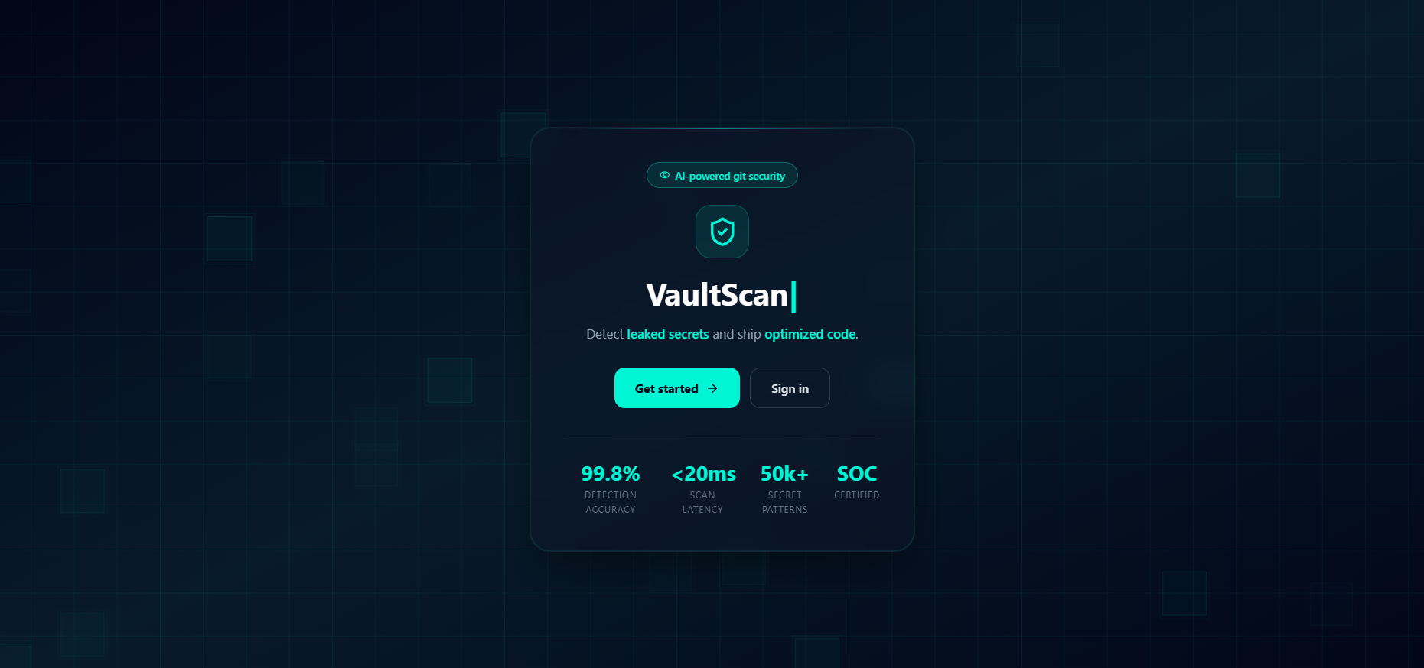
Figure 1 VaultScan - The Scanner App

Key Features of Proposed System:
- On-demand scanning of public GitHub repositories
- Hybrid detection using regex (signature-based) + Shannon Entropy
- Structured storage of findings (user-wise and scan-wise segregation)
- Interactive dashboards with risk classification (Critical, High, Medium, Low)
- Detailed vulnerability insights including file path and line number
- Heatmap visualization for tracking incidents over time (e.g., last 90 days)
- Admin-level analytics for monitoring users and overall system activity

Requirement Elicitation
Requirement elicitation is the process of identifying, analyzing, and documenting the functional and non-functional requirements of a software system. It forms the foundation of software development by ensuring that the developed application addresses the actual problem while meeting user expectations and technical constraints. For the development of VaultScan, the requirement elicitation process focused on understanding the limitations of existing repository security solutions and identifying the features necessary to develop a comprehensive repository secret detection platform.

The initial stage of requirement elicitation involved studying the existing approaches used for detecting exposed secrets in software repositories. Various secret detection tools, static code analysis techniques, and repository scanning methodologies were analyzed to understand their capabilities and shortcomings. This study revealed that while existing solutions effectively identify known secret patterns, many lack integrated dashboards, historical scan tracking, role-based access control, and contextual explanations that help developers understand the severity of detected vulnerabilities.

The project requirements were further refined through continuous discussions with the industry mentor during the internship. These discussions helped in identifying practical challenges faced by developers while managing repository security and provided valuable guidance regarding system architecture, module design, technology selection, and implementation strategy. Regular feedback throughout the development process enabled gradual refinement of both functional and user interface requirements.

The functional requirements were derived by considering the complete workflow of repository security analysis. The system was required to authenticate users securely, accept GitHub repository URLs, retrieve repository contents, detect exposed secrets using automated scanning techniques, classify vulnerabilities according to their severity, store scan history, and present the findings through an interactive dashboard. During the later stages of development, an additional requirement emerged to provide AI-assisted security analysis. This resulted in the integration of the Groq API, enabling the system to generate contextual explanations of detected vulnerabilities along with practical remediation recommendations.

In addition to functional requirements, several non-functional requirements were also identified. The application was expected to provide fast repository scanning, maintain secure handling of user credentials through JWT-based authentication, ensure reliable database operations, support modular architecture for future enhancements, and deliver an intuitive user interface that minimizes operational complexity. Scalability and maintainability were also considered important to ensure that additional detection techniques and repository platforms could be incorporated in future versions of the system.

The requirement elicitation process was iterative in nature. As individual modules were implemented and tested, new observations and improvement opportunities were identified. Feedback received during development led to enhancements such as improved dashboard visualization, optimized repository scanning workflows, historical vulnerability tracking, and the addition of the AI-powered review module. This iterative refinement ensured that the final system addressed both the original project objectives and the practical requirements encountered during implementation.

Overall, the requirement elicitation process established a clear understanding of the problem domain and provided a structured roadmap for the design and development of VaultScan. By systematically identifying functional needs, technical constraints, and user expectations, it ensured that the developed system remained aligned with the objectives of the industrial internship while addressing a real-world cybersecurity challenge.

Input–Process–Output (IPO) Analysis

Input–Process–Output (IPO) Analysis is a fundamental system analysis technique used to understand how a software system transforms user inputs into meaningful outputs through a sequence of processing activities. It provides a high-level representation of the overall workflow and helps identify the interaction between different system components. For the VaultScan system, the IPO model illustrates the complete repository scanning process, beginning with user input and ending with vulnerability visualization and AI-assisted security analysis.

The primary inputs to the system are provided by authenticated users. These inputs include user credentials for authentication, GitHub repository URLs for initiating repository scans, and user requests for viewing historical scan reports or generating AI-based security reviews. Before processing, all user inputs undergo validation to ensure correctness, authenticity, and compliance with the expected input format.

After successful validation, the system initiates a sequence of processing operations. The repository information is retrieved using the GitHub API or local Git cloning mechanisms. The scanning engine then analyzes the repository files using Regular Expression (Regex) pattern matching to detect known secret formats, while Shannon Entropy Analysis identifies randomly generated or unknown credentials with high entropy values. The detected findings are categorized according to predefined severity levels and securely stored in the MongoDB database for future reference.

As an additional layer of analysis, the processed findings are submitted to the AI review module through the Groq API. The AI module examines the detected vulnerabilities, generates contextual explanations regarding their security implications, assesses their potential impact, and recommends appropriate remediation measures. This enhances the usability of the system by helping users understand the detected vulnerabilities instead of simply presenting raw scan results.

Finally, the processed information is presented to the user through an interactive dashboard. The dashboard provides repository-wise scan summaries, vulnerability classifications, historical scan records, graphical analytics, and AI-generated security reviews. This structured flow ensures efficient repository analysis while maintaining accuracy, security, and ease of use throughout the scanning process.

Functional Requirement Analysis:
Functional requirements define the core operations and functionalities that the system must perform to meet user needs. These requirements describe what the system should do and how different components interact to deliver the expected output. In the VaultScan system, functional requirements are designed to ensure smooth workflow from user input to vulnerability detection and result visualization. Each functionality is structured in a modular manner, allowing independent execution while contributing to the overall system performance. The system is built to support both user-level and administrative-level operations, ensuring flexibility, scalability, and ease of use.

User Authentication and Authorization
The system must provide a secure authentication mechanism that allows users to register, log in, and access protected features. Authentication is implemented using token-based mechanisms such as JWT to ensure secure communication between client and server. The system should validate user credentials, generate secure tokens, and restrict access to authorized users only. Additionally, role-based access control must be implemented to differentiate between normal users and administrators, ensuring that sensitive operations are accessible only to authorized roles.
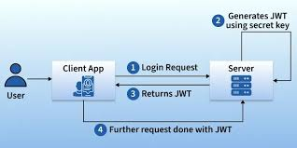
Figure 2 User Auth Flow

Repository Scanning Functionality
The system must allow users to initiate scanning of public GitHub repositories by providing a repository URL. Upon receiving the input, the system validates the URL and fetches repository data using GitHub API or local Git cloning. The scanning module processes repository files efficiently, ensuring that both current code and historical commits can be analyzed. This functionality is central to the system, enabling automated detection of sensitive data without manual intervention.

Secret Detection Mechanism
The system must detect exposed sensitive information such as API keys, tokens, passwords, and connection strings. Detection is performed using a hybrid approach that combines signature-based scanning (regex patterns) and entropy-based analysis (Shannon Entropy). This ensures improved accuracy in identifying both known and unknown secret patterns. The system must classify detected secrets based on predefined criteria and ensure minimal false positives while maintaining detection reliability.

Risk Classification and Categorization
The system must categorize detected vulnerabilities into different risk levels such as Critical, High, Medium, and Low. This classification is based on the type of secret, its exposure level, and potential impact. Risk categorization helps users prioritize actions and focus on high-risk vulnerabilities first. The system should also provide clear indicators and labels to improve understanding and decision-making.

Data Storage and Management
The system must store all scan results, findings, and user data in a structured database. Each scan should be associated with a specific user and timestamp, ensuring proper tracking and traceability. The database should efficiently manage large volumes of data, including scan history and vulnerability records. Data segmentation must be implemented to ensure that users can only access their own scan results while administrators can access system-wide data.

Dashboard Visualization
The system must provide an interactive dashboard to display scan results in a clear and structured manner. The dashboard should include features such as:
- Summary of vulnerabilities
- Risk distribution (Critical, High, Medium, Low)
- Detailed findings with file path and line number
- Visual representations such as charts and graphs
The dashboard enhances usability by transforming raw data into meaningful insights, enabling users to quickly understand the security status of their repositories.

Historical Tracking and Analytics
The system must maintain a history of all scans performed by users. This allows users to track previously detected vulnerabilities and monitor improvements over time. Analytical features such as trend graphs and heatmaps (e.g., incidents over the past 90 days) should be included to provide deeper insights into repository security. This functionality supports long-term monitoring and better decision-making.

Admin Control and Monitoring
The system must provide an admin module with advanced control and monitoring capabilities. Administrators should be able to:
- View all users and their activities
- Monitor system-wide scan data
- Analyze overall risk trends
- Manage user accounts
This ensures proper governance, system security, and efficient management of the platform.

Error Handling and Validation
The system must handle errors effectively to ensure smooth operation. Input validation should be performed for repository URLs and user data. The system should provide meaningful error messages for invalid inputs, failed scans, or API issues. Proper exception handling must be implemented to prevent system crashes and ensure reliability.

Non-Functional Requirement Analysis:
Non-functional requirements define the quality attributes and performance characteristics of a system rather than the specific functionalities it performs. These requirements ensure that the system operates efficiently, securely, and reliably under different conditions. In the VaultScan system, non-functional requirements play a crucial role in ensuring that the application is scalable, responsive, and capable of handling real-world workloads. These requirements focus on system performance, security, usability, and maintainability, which are essential for delivering a robust and production-ready application.

Performance
The system must provide efficient performance while scanning repositories and processing data. It should be capable of handling small to moderately large repositories with minimal delay. The response time for API requests should be optimized to ensure a smooth user experience. Asynchronous processing techniques should be used in the backend to handle multiple requests efficiently without blocking system operations. Performance optimization strategies such as efficient database queries, caching, and limiting unnecessary API calls should be implemented to improve system speed.

Scalability
The system should be designed to handle increasing numbers of users and large volumes of data without degradation in performance. As the number of repository scans and stored findings grows, the system must scale efficiently. The use of technologies such as MongoDB and Node.js supports horizontal scalability. The architecture should allow future enhancements such as cloud deployment and microservices integration, ensuring that the system can adapt to higher workloads and expanded functionality.

Security
Security is a critical requirement for the VaultScan system, as it deals with sensitive data and authentication processes. The system must ensure secure user authentication using mechanisms such as JWT tokens. Passwords must be encrypted using secure hashing algorithms before storage. All API endpoints should be protected against unauthorized access. Additionally, sensitive information detected during scanning should be masked before being displayed to users to prevent misuse. The system should also implement validation and sanitization techniques to protect against common vulnerabilities such as injection attacks.

Reliability
The system must operate consistently without failures under normal usage conditions. It should be capable of handling errors gracefully without crashing or losing data. Proper error handling mechanisms must be implemented across all modules, including API requests, database operations, and scanning processes. The system should maintain data integrity and ensure that all scan results are stored accurately. Reliability ensures that users can trust the system for consistent and dependable performance.

Usability
The system should provide a user-friendly interface that is easy to understand and navigate. Users should be able to perform actions such as logging in, initiating scans, and viewing results without technical complexity. The dashboard should present information in a clear and structured format, using visual elements such as charts and summaries to enhance understanding. Minimal training should be required for users to interact with the system effectively, ensuring wider usability.

Maintainability
The system should be designed in a modular and structured manner to allow easy maintenance and updates. Code should be organized into components such as controllers, routes, and services, making it easier to debug and extend. Proper documentation and coding standards should be followed to ensure that future developers can understand and modify the system efficiently. Maintainability ensures long-term sustainability of the application.

Availability
The system should be available for use whenever required, with minimal downtime. It should be capable of handling multiple user requests simultaneously without service interruption. In future deployments, hosting on cloud platforms can further improve system availability and uptime. Ensuring availability is important for maintaining user trust and system reliability.

Compatibility
The system should be compatible with different browsers and devices to ensure accessibility for a wide range of users. The frontend should be responsive and adaptable to different screen sizes.

Methodology

Methodology Overview
Methodology covers System design is a crucial phase in the development of any software system, as it defines how the system components are structured and how they interact with each other to achieve the desired functionality. In the VaultScan system, the design is focused on building a scalable, modular, and efficient architecture that can handle repository scanning, data processing, and result visualization in a seamless manner. The design ensures that each component of the system operates independently while contributing to the overall workflow.
The system is developed using the MERN stack, which provides a strong foundation for building full-stack applications. This combination enables smooth communication between the frontend, backend, and database layers. The design follows a clear separation of concerns, where each layer is responsible for a specific set of tasks. This separation improves maintainability and allows easier debugging and future enhancements.

A modular approach is adopted in the system design, where the application is divided into smaller components such as authentication, scanning engine, dashboard, and database management. Each module is designed to perform a specific function, reducing system complexity and improving code organization. This approach also allows independent testing and scaling of individual modules without affecting the entire system.

The design also incorporates integration with external services such as the GitHub API, which enables real-time access to repository data. This integration ensures that the system can work on actual repositories and provide meaningful insights. Additionally, security mechanisms such as JWT-based authentication are included at the design level to ensure safe communication between system components.

Overall, the system design of VaultScan ensures a balance between performance, scalability, and usability. It provides a structured framework that supports efficient data flow, secure operations, and real-time processing, making the system suitable for practical and real-world applications.

System Implementation Details
The implementation of VaultScan follows a modular and structured development approach, ensuring maintainability, scalability, and efficiency. The system is developed using the MERN stack, which enables seamless interaction between the frontend, backend, and database components.
The frontend is implemented using React.js, which allows the creation of reusable components and dynamic user interfaces. State management is handled efficiently to ensure smooth rendering of data, especially when displaying scan results and dashboards. Tailwind CSS is used for styling, providing a modern and responsive design.

The backend is developed using Node.js and Express.js, which handle API requests and business logic. RESTful APIs are designed to manage communication between the client and server. The backend is responsible for authentication, scan processing, and database interactions.
MongoDB is used as the database due to its flexibility in handling semi-structured data. Collections are designed to store users, scans, findings, and clean records efficiently. Indexing techniques can be applied to improve query performance.

The integration with GitHub API enables real-time access to repository data. The system fetches files from repositories and processes them using a scanning engine. Regular expressions are used to identify patterns corresponding to sensitive data such as API keys and tokens.
Overall, the implementation ensures a smooth workflow from user input to result visualization, making the system reliable and efficient.

System Architecture
The system architecture of VaultScan is designed using a three-tier architecture model, which divides the system into frontend, backend, and database layers. This architectural pattern ensures clear separation of responsibilities and improves system scalability and maintainability. Each layer performs a distinct role while communicating with other layers through well-defined interfaces.

The frontend layer is responsible for user interaction and interface rendering. It is built using React.js, which enables the creation of dynamic and responsive user interfaces. This layer handles user inputs, displays scan results, and provides visualizations such as dashboards and charts. By using a component-based architecture, the frontend ensures reusability and consistency across the application.

The backend layer acts as the core processing unit of the system. It is developed using Node.js and Express.js, which handle API requests, authentication, and business logic. The backend processes user requests, communicates with the database, and interacts with external services such as the GitHub API. It also manages the scanning workflow by triggering the scanner engine and processing its output.

The database layer uses MongoDB to store user data, scan results, findings, and historical records. The NoSQL structure allows flexible data storage and efficient handling of large datasets. Proper indexing and schema design ensure fast data retrieval and scalability as the system grows.

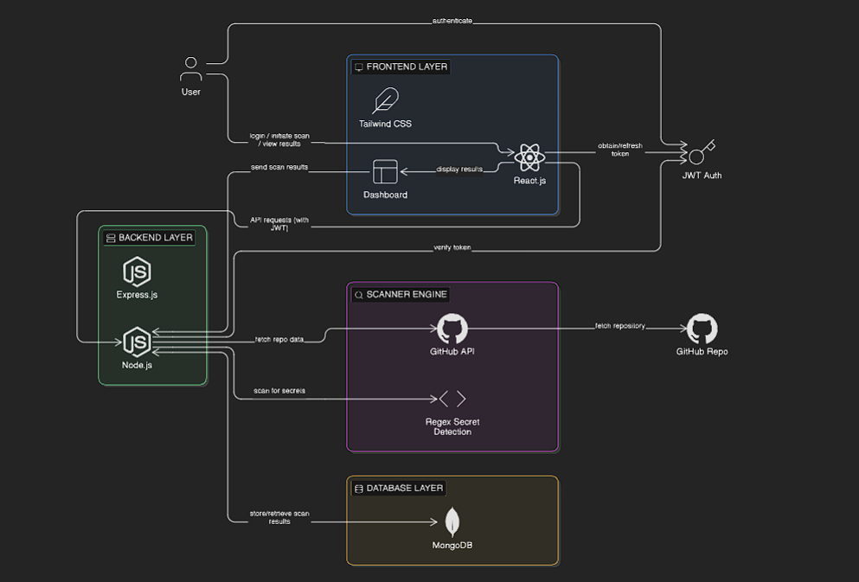
Figure 3 System Architecture of VaultScan
In addition to these layers, the architecture includes a scanner engine and external API integration. The scanner engine performs repository analysis and secret detection, while the GitHub API provides access to repository data. This layered architecture ensures efficient data flow, modular design, and high system performance.

Data Flow Diagram (DFD)
The Data Flow Diagram (DFD) represents how data moves within the VaultScan system and how different components interact during execution. It provides a clear understanding of the flow of information from input to output, highlighting the processes involved in repository scanning and result generation.
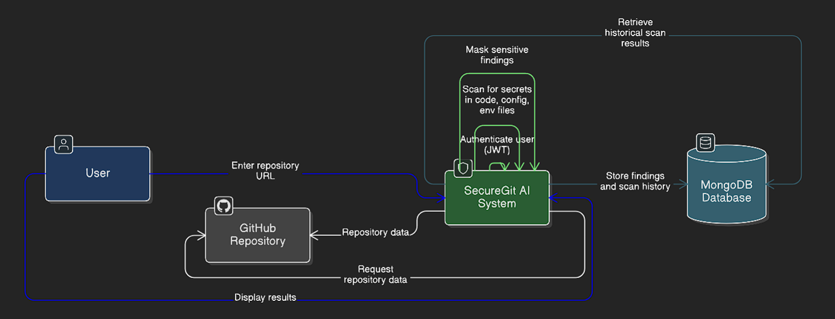
Figure 4 Data Flow Diagram

The process begins with the user, who acts as the external entity. The user provides input in the form of a GitHub repository URL through the frontend interface. This input is then transmitted to the backend system, where it undergoes validation and authentication. The authentication process ensures that only authorized users can initiate scanning operations.

Once the input is validated, the system communicates with the GitHub API to fetch repository data. This data includes source code files, configuration files, and other relevant content required for analysis. The scanner engine then processes this data using pattern-matching techniques to detect sensitive information such as API keys, tokens, and credentials.

After processing, the detected findings are stored in the MongoDB database. The system organizes the data based on user and scan details, enabling efficient tracking and retrieval. The processed results are then sent back to the frontend, where they are displayed through dashboards and visual components.

The DFD highlights the structured and sequential nature of the system, ensuring smooth data flow and minimal errors. It also demonstrates how different components collaborate to achieve the overall functionality of the application, making the system efficient and reliable.

Entity Relationship Diagram (ERD)
The Entity Relationship Diagram (ERD) represents the database structure of the VaultScan system and defines the relationships between different data entities. It provides a logical view of how data is organized, stored, and connected within the system. The ERD ensures that the database design is efficient, consistent, and scalable.
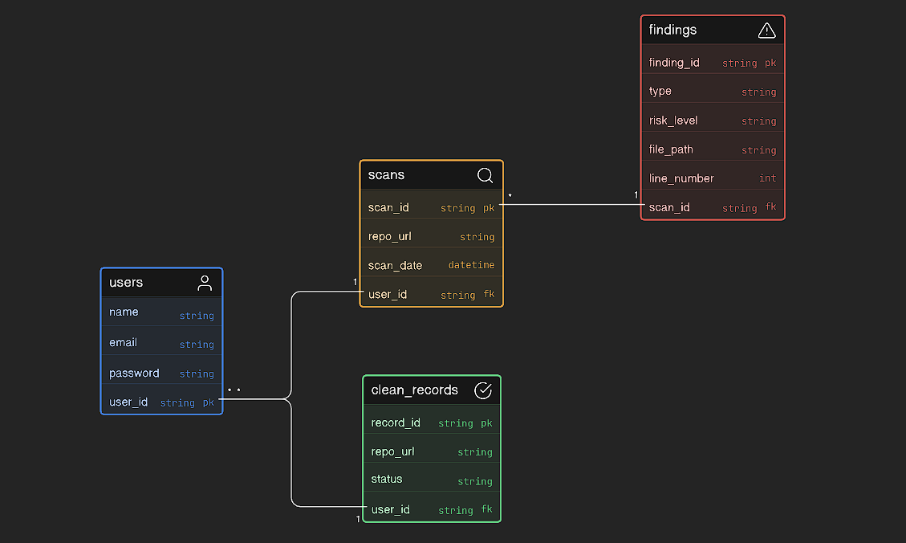
Figure 5 Entity Relationship Diagram (ERD) of VaultScan
The primary entities in the system include Users, Scans, Findings, and Clean Records. The Users entity stores information about registered users, including authentication details. The Scans entity represents each repository scanning operation performed by a user, maintaining details such as repository URL and scan timestamp.

The Findings entity is one of the most critical components, as it stores all detected vulnerabilities and exposed secrets. Each finding is associated with a specific scan and includes attributes such as type of secret, risk level, file path, and line number. This structured representation allows detailed analysis of security issues.
The Clean Records entity is used to track repositories that do not contain vulnerabilities or have been resolved. This helps users monitor improvements in repository security over time. Relationships between entities are established using primary and foreign keys, ensuring referential integrity and consistency.

The ERD follows normalization principles to reduce redundancy and improve data efficiency. It ensures that data is stored logically and can be retrieved quickly. This structured database design supports scalability and efficient handling of large volumes of scan data.

Modules of the System
The VaultScan system is designed using a modular architecture, where the overall application is divided into multiple independent modules, each responsible for performing a specific set of tasks. This modular approach improves maintainability, scalability, and ease of development, as changes in one module do not directly impact others. It also allows individual components to be tested, updated, and optimized independently, ensuring better system reliability and flexibility.

Each module in the system is designed to handle a distinct functionality, ranging from user authentication to repository scanning and result visualization. These modules work together in a coordinated manner to ensure a smooth workflow from user input to output generation. By separating responsibilities, the system avoids complexity and promotes clean code organization, which is essential for long-term sustainability and future enhancements.

The interaction between modules is managed through well-defined interfaces and APIs. For example, the frontend communicates with the backend through RESTful APIs, while the backend interacts with the database and scanner engine. This layered communication ensures efficient data flow and minimizes dependencies between components. The modular structure also makes it easier to integrate new features such as additional detection techniques or external service integrations.

The modular design aligns with industry-standard software development practices, enabling better collaboration and scalability. Each module can be extended or replaced without affecting the entire system, making the architecture adaptable to future requirements. This design approach ensures that the system remains robust, efficient, and capable of handling increasing complexity over time.

Modules of the System:
- Authentication Module – Handles user registration, login, and secure access using JWT
- Scanner Module – Performs repository analysis and detects sensitive information
- Dashboard Module – Displays scan results, risk distribution, and analytics
- Admin Module – Provides system-level monitoring, user management, and analytics
- Database Module – Manages storage of users, scans, findings, and historical data

Authentication Module
The authentication module is responsible for managing user identity and ensuring secure access to the system. It provides functionalities such as user registration, login, and session management. This module plays a critical role in protecting system resources and ensuring that only authorized users can access sensitive features such as repository scanning and data visualization.

The system uses JSON Web Tokens (JWT) for implementing authentication. When a user logs in, a secure token is generated and sent to the client. This token is then used to authenticate subsequent API requests. The use of token-based authentication ensures a stateless and scalable system, as the server does not need to maintain session data.

The module also supports role-based authorization. This ensures that different types of users, such as normal users and administrators, have access to appropriate functionalities. Admin users are granted additional privileges such as viewing system-wide analytics and managing user accounts.
Security is a major focus of this module. Passwords are stored in encrypted form, and secure validation mechanisms are implemented to prevent unauthorized access. The module also handles token validation and expiration to maintain session security.

Scanner Module
The scanner module is the core component of the VaultScan system, responsible for analyzing GitHub repositories and detecting sensitive information. It automates the process of identifying exposed secrets, eliminating the need for manual code review. This module directly addresses the primary objective of the project, which is to enhance repository security through automated detection.

The scanner operates by fetching repository data using the GitHub API or local Git cloning. Once the data is retrieved, it processes files and applies detection techniques such as regular expressions and entropy analysis. These techniques help identify patterns associated with API keys, tokens, passwords, and other sensitive data.

The module is designed to handle different types of files, including source code, configuration files, and environment variables. It ensures that all relevant data is scanned thoroughly to maximize detection accuracy. The scanner also classifies detected secrets based on risk levels, providing meaningful insights for users.

Efficiency and performance are key considerations in the design of this module. The scanning process is optimized to handle large repositories and multiple requests. By automating detection and classification, the scanner module significantly improves speed, accuracy, and reliability compared to traditional methods.

Features of Scanner Module:
- Repository fetching using GitHub API or Git cloning
- Pattern-based detection using regex
- Entropy-based detection for hidden secrets
- Analysis of multiple file types
- Risk classification of detected vulnerabilities

API Design
The API design of the VaultScan system is based on RESTful architecture, which enables structured and efficient communication between the frontend and backend components. APIs act as the interface through which the client sends requests and receives responses, ensuring smooth data exchange across different layers of the system. A well-defined API structure is essential for maintaining scalability, modularity, and ease of integration with external services.

The APIs are organized into different categories based on functionality, such as authentication, scanning, dashboard, and admin operations. Each API endpoint is designed to handle a specific task, following standard HTTP methods like GET, POST, PUT, and DELETE. This structured approach ensures clarity in operations and simplifies debugging and maintenance.
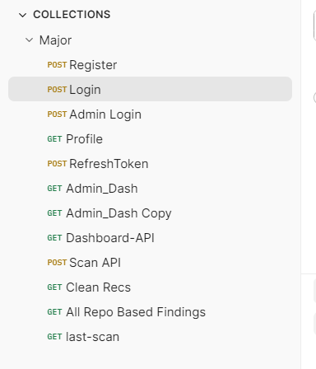
Figure 6 API Postman
Security is a key aspect of API design in the system. All protected routes require authentication using JSON Web Tokens (JWT), ensuring that only authorized users can access sensitive operations. Input validation and error handling mechanisms are implemented to prevent invalid requests and ensure system stability. The APIs are designed to return meaningful responses, including status codes and messages, which improve usability and debugging.

The API design also supports scalability and future enhancements. Since each endpoint is independent, new features can be added without affecting existing functionalities. The modular structure allows easy integration with additional services such as external APIs or mobile applications. Overall, the API design ensures efficient communication, secure access, and reliable system performance.
API Categories:
- Authentication APIs for user registration, login, and session management
- Scanning APIs for initiating repository scans and retrieving findings
- Dashboard APIs for visualization and analytics data
- Admin APIs for system monitoring and user management

Authentication and Authorization Design
The authentication and authorization design ensures secure access to the system and protects sensitive data from unauthorized users. This component is responsible for verifying user identity and controlling access to different functionalities based on user roles. It plays a critical role in maintaining system security and integrity.

The system uses JSON Web Tokens (JWT) for implementing authentication. When a user logs in, a token is generated and sent to the client. This token is included in subsequent API requests to verify user identity. The stateless nature of JWT ensures scalability, as the server does not need to maintain session data.

In addition to authentication, the system implements role-based authorization. Users are categorized into roles such as normal users and administrators, each having access to different features. For example, administrators can view system-wide analytics and manage users, while normal users can only access their own data. This separation ensures proper access control and prevents misuse of system functionalities.

The design also includes security measures such as password hashing, token expiration, and protected routes. These measures ensure that user data remains secure and that unauthorized access is prevented. Overall, the authentication and authorization design provides a secure and scalable mechanism for managing user access within the system.

Scanner Engine Design
The scanner engine is the most critical component of the VaultScan system, as it is responsible for detecting exposed secrets within GitHub repositories. This module is designed to automate the process of identifying sensitive information, ensuring faster and more reliable detection compared to manual methods.

The scanner operates by first fetching repository data using the GitHub API or local Git cloning. Once the data is retrieved, it parses the files and extracts relevant content for analysis. The system then applies regular expressions to detect predefined patterns associated with sensitive data such as API keys, tokens, and credentials.

In addition to pattern-based detection, the scanner uses entropy analysis to identify high-randomness strings that may represent hidden or encrypted secrets. This hybrid approach improves detection accuracy by combining known pattern matching with heuristic analysis. The scanner also classifies detected secrets into different risk levels, helping users prioritize vulnerabilities.

The design of the scanner focuses on efficiency and scalability. It is capable of handling multiple repositories and processing large datasets with optimized performance. By integrating detection, classification, and processing into a single module, the scanner engine ensures accurate and efficient vulnerability detection.

Data Processing and Transformation Design
Data processing and transformation play a crucial role in converting raw repository data into meaningful and structured information that can be analyzed and visualized. In the VaultScan system, the data retrieved from GitHub repositories is initially unstructured and requires multiple processing steps before it can be stored or presented to the user. This design ensures that the system produces accurate, clean, and actionable insights.

The process begins with filtering relevant files from the repository. Not all files are useful for secret detection, so the system identifies and selects files such as source code, configuration files, and environment files. This filtering step improves efficiency by reducing unnecessary processing and focusing only on relevant data.

Once the files are selected, the system extracts key information such as file paths, content, and line numbers. The scanner engine then analyzes this data using regex and entropy-based techniques to detect sensitive information. After detection, the raw findings are transformed into a structured format that includes attributes like type of secret, risk level, and location within the file.

An important part of transformation is masking sensitive information before displaying it to users. This ensures that while vulnerabilities are identified, the actual secrets are not exposed, maintaining system security. The processed data is then stored in the database in a standardized format, allowing efficient retrieval and analysis.

Overall, the data processing and transformation design ensures that raw input data is converted into structured, secure, and meaningful output. This improves system accuracy, enhances performance, and supports effective visualization and decision-making.

Frontend UI/UX Design Approach
The frontend design of the VaultScan system focuses on providing a clean, responsive, and user-friendly interface that allows users to interact with the system efficiently. Since the application deals with technical data such as vulnerabilities and scan results, the design prioritizes clarity and ease of understanding. The goal is to ensure that users, even with limited technical background, can navigate the system and interpret results without difficulty.

The interface is developed using React.js, which enables a component-based architecture for building reusable and maintainable UI elements. This approach ensures consistency across different parts of the application, such as dashboards, forms, and navigation components. Tailwind CSS is used for styling, allowing rapid development of modern and responsive layouts. The combination of these technologies ensures that the interface is visually appealing while maintaining high performance.

Special attention is given to dashboard design, as it is the primary area where users interact with scan results. Data is presented using structured layouts, including tables, cards, and visual indicators such as risk levels. This helps users quickly identify critical issues without going through raw data. The use of clear labels, color coding for risk levels, and organized sections enhances readability and improves decision-making.

The system also ensures responsiveness across different devices and screen sizes. The layout adapts dynamically, allowing users to access the application on desktops, tablets, or smaller screens without loss of usability. Navigation is kept simple and intuitive, minimizing the number of steps required to perform key actions such as scanning a repository or viewing results.

Overall, the UI/UX design is focused on simplicity, consistency, and usability. It ensures that complex security data is presented in an understandable manner, improving user experience and making the system more effective in real-world usage.

Error Handling Design
Error handling is an essential aspect of the VaultScan system, as it ensures stability, reliability, and a smooth user experience even when unexpected issues occur. Since the system involves multiple components such as frontend interactions, backend processing, external API communication, and database operations, errors can arise at various stages. A well-defined error handling mechanism is implemented to detect, manage, and respond to these errors effectively.

At the input level, validation mechanisms are applied to ensure that only correct and properly formatted data is processed by the system. For example, repository URLs are validated before initiating the scanning process, and user inputs such as login credentials are checked for correctness. This prevents unnecessary processing and reduces the chances of system failure due to invalid inputs.

On the backend, structured error handling is implemented using middleware and exception handling techniques. API responses are designed to return appropriate HTTP status codes along with meaningful error messages, which help both users and developers understand the issue. Try-catch blocks are used to manage runtime exceptions, ensuring that the system does not crash and continues to operate smoothly.

The system also handles errors related to external dependencies such as GitHub API failures or network issues. In such cases, fallback mechanisms and informative messages are provided to the user, ensuring transparency and preventing confusion. Logging mechanisms are implemented to record errors for debugging and future improvements.

Overall, the error handling design ensures that the system remains robust and user-friendly by managing failures gracefully. It minimizes disruptions, provides clear feedback to users, and supports efficient debugging and maintenance of the application.

Security Design Considerations
Security is a fundamental aspect of the VaultScan system, as it deals with user authentication, repository data, and detection of sensitive information. The system is designed with multiple layers of security to protect user data, prevent unauthorized access, and ensure safe handling of detected vulnerabilities. These measures are integrated at both the application and data levels to maintain overall system integrity.
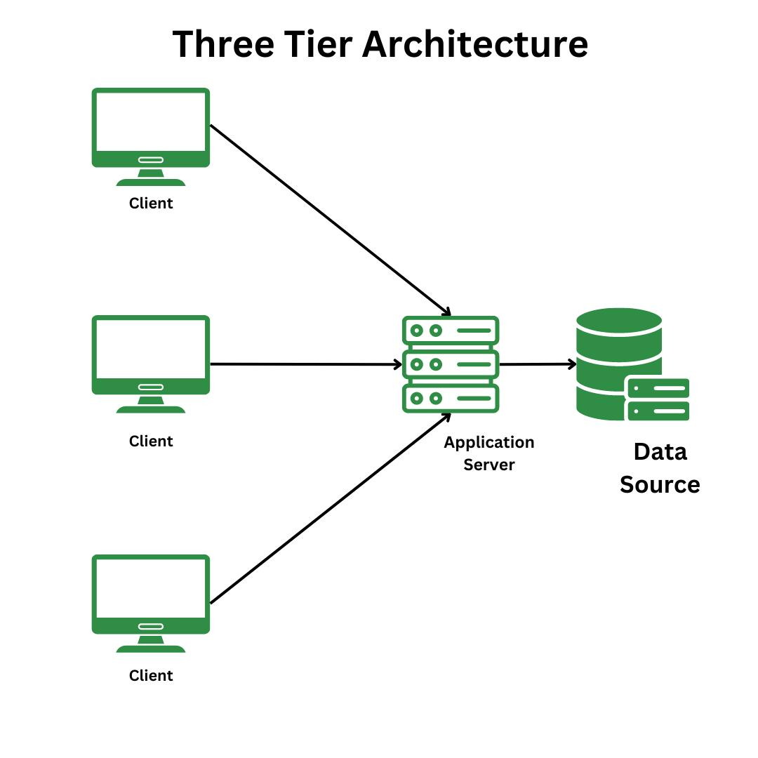
Figure 7 Three Tire Architecture
The system implements secure authentication using JSON Web Tokens (JWT), which ensures that only verified users can access protected resources. When a user logs in, a token is generated and used for validating subsequent requests. Passwords are never stored in plain text; instead, they are encrypted using secure hashing algorithms before being stored in the database. This reduces the risk of credential compromise.

Authorization mechanisms are also incorporated to control access based on user roles. The system differentiates between normal users and administrators, ensuring that sensitive operations such as user management and system analytics are restricted to authorized personnel only. This role-based access control enhances security and prevents misuse of system functionalities.

Another important consideration is the handling of detected sensitive data. The system ensures that exposed secrets are partially masked before being displayed to users. This prevents misuse of actual credentials while still informing users about vulnerabilities. Additionally, environment variables are used to store sensitive configuration data such as API keys, preventing exposure in the source code.

The system also includes protection against common web vulnerabilities through input validation, sanitization, and secure API design. Proper validation ensures that malicious inputs are not processed, reducing the risk of attacks such as injection or unauthorized access. Overall, the security design ensures that the system remains safe, reliable, and suitable for handling sensitive operations in real-world environments.

Performance Optimization Design
Performance optimization is a key consideration in the VaultScan system, as it directly affects user experience and system efficiency. Since the application involves repository scanning, data processing, and real-time result visualization, it is important to ensure that operations are performed with minimal delay and optimal resource utilization. The system is designed to handle these operations efficiently while maintaining responsiveness.

One of the primary optimization strategies is the use of asynchronous processing in the backend. Node.js enables non-blocking execution, allowing the system to handle multiple requests simultaneously without delaying other operations. This is particularly useful when scanning repositories, as file processing and API interactions can be executed in parallel, reducing overall execution time.

Database performance is also optimized through proper schema design and indexing techniques. MongoDB collections are structured to allow fast data retrieval, especially for frequently accessed data such as scan results and user information. Efficient query design ensures that unnecessary database operations are avoided, improving response time and reducing system load.
Another important aspect is minimizing unnecessary API calls. The system uses local Git cloning for large repositories instead of repeatedly calling the GitHub API, which helps avoid rate limits and improves performance. Additionally, frontend performance is enhanced by using efficient state management and minimizing unnecessary re-rendering of components.

Overall, the performance optimization design ensures that the system remains fast, responsive, and capable of handling moderate workloads efficiently. These optimizations improve user experience and ensure that the system performs reliably under different usage conditions.

Scalability Design
Scalability is an important aspect of the VaultScan system, as it determines the system’s ability to handle increasing numbers of users, larger repositories, and growing volumes of data over time. The system is designed with a scalable architecture to ensure that performance does not degrade as usage increases. This is achieved by adopting modular design principles and leveraging technologies that support horizontal and vertical scaling.

The use of a three-tier architecture contributes significantly to scalability. Since the frontend, backend, and database layers are separated, each layer can be scaled independently based on system requirements. For example, additional backend instances can be deployed to handle increased API requests, while the database can be optimized or distributed to manage larger datasets. This separation ensures flexibility in scaling without affecting the entire system.

The backend, built using Node.js, supports handling multiple concurrent requests efficiently due to its non-blocking I/O model. This allows the system to manage multiple scanning operations simultaneously. MongoDB further enhances scalability with its flexible schema design and support for distributed databases, enabling the system to store and process large volumes of data without significant performance issues.

The modular structure of the system also supports scalability. Components such as the scanner engine, authentication module, and dashboard can be extended or optimized independently. In future implementations, the system can be migrated to cloud-based infrastructure, enabling features such as load balancing, auto-scaling, and distributed processing.

Overall, the scalability design ensures that the system can grow with increasing demand while maintaining performance and reliability. It prepares the system for future enhancements and real-world deployment scenarios where higher workloads are expected.

Implementation

The implementation phase of the VaultScan system focuses on converting the designed architecture into a working application by integrating frontend, backend, database, and external services. This phase ensures that all system components operate together seamlessly to deliver the intended functionality. The system is developed using the MERN stack, which provides a unified development environment and enables efficient communication between different layers of the application.

The implementation follows a modular and structured approach, where each component such as authentication, scanning engine, and dashboard is developed and tested independently before integration. This approach improves code maintainability and allows easier debugging and future enhancements. The system is designed to handle real-time repository scanning, process large amounts of data, and present results in a user-friendly format.

Special emphasis is placed on integrating the scanner engine with the backend and database. The system fetches repository data, processes it using detection algorithms, and stores the results efficiently. The frontend then retrieves this data through APIs and displays it using interactive dashboards. This end-to-end implementation ensures smooth data flow and consistent system behavior.

Overall, the implementation ensures that the system is functional, scalable, and aligned with the design objectives. It demonstrates how different technologies and modules are combined to build a complete and practical solution for detecting exposed secrets in repositories.

Technology Stack
The VaultScan system is built using a modern technology stack that supports full-stack development and efficient system performance. The frontend is developed using React.js, which enables the creation of dynamic and reusable user interface components. Tailwind CSS is used for styling, providing a responsive and modern design, while Axios is used to handle API communication between the client and server.

The backend is implemented using Node.js and Express.js, which provide a scalable environment for handling API requests, business logic, and asynchronous operations. These technologies enable efficient processing of scanning tasks and seamless integration with external services such as the GitHub API.

MongoDB is used as the database due to its flexibility in handling semi-structured data. It efficiently stores user information, scan results, findings, and historical records. The use of a NoSQL database allows easy scaling and faster data retrieval.

Additional tools such as JWT are used for secure authentication, ensuring protected access to system resources. Nodemailer is used for handling email-related functionalities, such as password reset or notifications. The GitHub API is integrated to fetch repository data for scanning purposes. This combination of technologies ensures a robust and efficient implementation of the system.

Features Implemented
The implemented system includes several core features that address the objectives of the project and improve repository security. These features are designed to work together to provide a complete solution for detecting and analyzing exposed secrets.

The system includes a secure authentication mechanism that ensures only authorized users can access the application. The repository scanning engine allows users to analyze public GitHub repositories and detect sensitive information automatically. Detected secrets are categorized based on risk levels, helping users prioritize critical vulnerabilities.

Interactive dashboards are implemented to visualize scan results in a structured and user-friendly manner. These dashboards provide insights into vulnerability distribution, historical trends, and overall repository security. Additionally, an admin module is implemented to provide system-level monitoring, user management, and analytics.

Scanner Implementation
The scanner implementation forms the central intelligence layer of the VaultScan system, designed to automatically detect sensitive information such as API keys, tokens, and credentials from source code repositories. The scanning process begins by extracting repository metadata from the provided GitHub URL and identifying the default branch using the GitHub API. The system then retrieves the complete file tree of the repository in a recursive manner. Based on repository size, an adaptive strategy is used: smaller repositories are scanned directly via API calls, while larger repositories are cloned locally. This hybrid approach optimizes performance, reduces API rate-limit issues, and ensures scalability when dealing with large-scale repositories.

Once the repository data is acquired, the scanner filters relevant files using predefined rules (such as ignoring binaries, dependencies, or minified files). The core detection mechanism is built on pattern matching algorithms, primarily using Regular Expressions (Regex). Each secret type (for example AWS keys, JWT tokens, passwords, private keys) is represented as a signature consisting of a regex pattern, a risk level, and a label. The scanner processes file content line-by-line and applies these regex patterns to identify matches. This approach is deterministic and highly efficient, with a time complexity proportional to the size of the input text, making it suitable for real-time scanning systems.

To enhance detection beyond static patterns, the system integrates Shannon Entropy, an algorithm from information theory that measures the randomness of a string. Secrets such as API keys and tokens tend to exhibit high entropy due to their unpredictable character distribution. The entropy $H$of a string is calculated as:
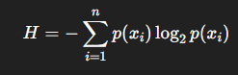
Figure 8 Shannon Entropy
where $p(x_{i})$represents the probability of occurrence of each character in the string. If the computed entropy exceeds a predefined threshold (typically between 3.5 and 5.0), the string is flagged as a potential secret. This allows the system to detect unknown or obfuscated secrets that do not match predefined regex signatures, significantly improving recall.

The implementation also includes parallel processing using asynchronous execution (Promise-based concurrency control), which significantly reduces scanning time by processing multiple files simultaneously while respecting API limits. In clone mode, additional analysis is performed on Git diffs to detect secrets introduced in recent commits, enabling incremental security auditing. After detection, results are normalized and deduplicated using hashing techniques to avoid redundant findings. Each finding is then classified into risk categories such as Critical, High, Medium, or Low based on predefined severity rules associated with each signature.
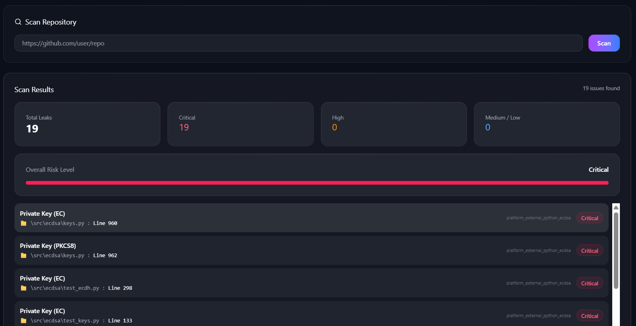
Figure 9 Scanner Class
Finally, the structured findings are returned with metadata including repository name, file path, line number, detected value, and source of detection (API or local scan). This data is stored in the database for visualization, reporting, and further analysis. Overall, the scanner combines deterministic pattern matching, probabilistic entropy analysis, and scalable system design principles to provide an efficient and reliable solution for automated secret detection in modern software repositories.

Authentication Implementation
Authentication in the VaultScan system is implemented using JSON Web Tokens (JWT), providing a secure and scalable method for managing user sessions. When a user logs in, their credentials are verified against stored data, and a token is generated upon successful authentication. This token is then sent to the client and stored securely.

For subsequent requests, the token is included in the request headers, allowing the backend to verify the user’s identity. This approach eliminates the need for maintaining server-side sessions, making the system stateless and scalable. Token expiration and validation mechanisms are implemented to enhance security.

This implementation ensures that only authorized users can access protected routes and functionalities. It also supports role-based access control, allowing different levels of access for normal users and administrators. Overall, the authentication system provides a secure and efficient way to manage user access.

Frontend Implementation
The frontend implementation focuses on creating an interactive and responsive user interface that allows users to easily interact with the system. React.js is used to build reusable components, ensuring consistency and maintainability across the application. The use of component-based architecture simplifies development and enhances code organization.

Tailwind CSS is used to design responsive layouts, ensuring that the application works smoothly across different devices and screen sizes. The frontend is designed to display complex data such as scan results and risk analysis in a clear and structured manner, improving user experience.

Axios is used for communication between the frontend and backend, enabling efficient handling of API requests and responses. State management techniques are applied to ensure smooth rendering of data and real-time updates. Overall, the frontend implementation provides a seamless and user-friendly experience.

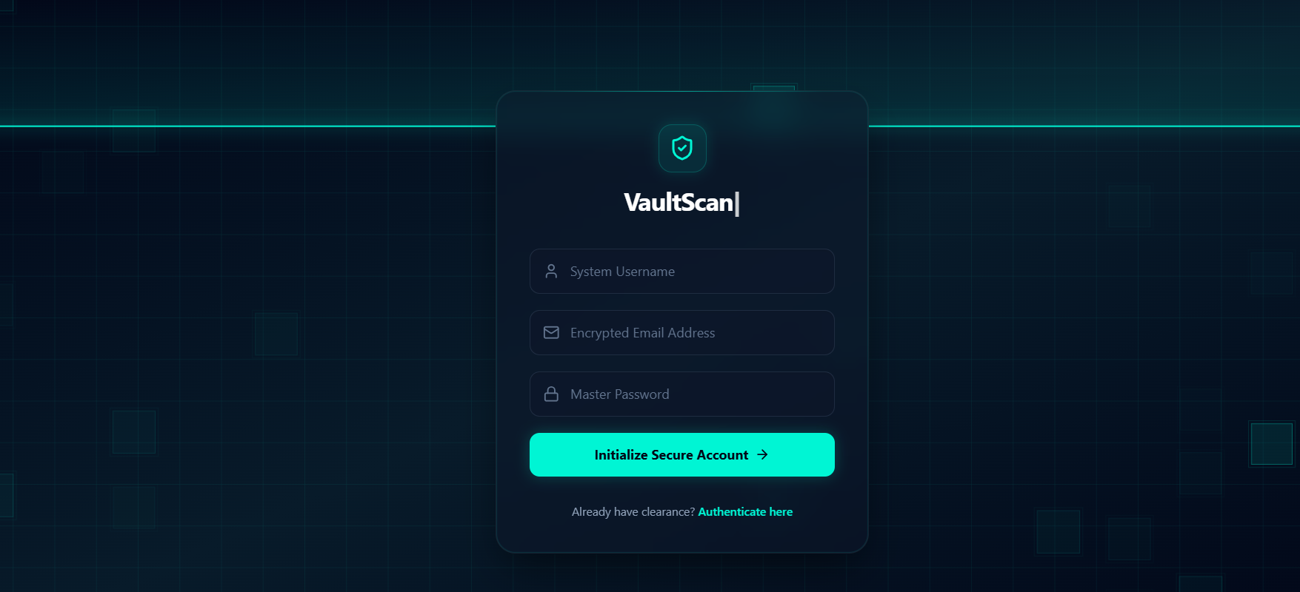
Figure 10 Register Page Component

Backend Implementation
The backend implementation is responsible for handling all server-side operations, including API routing, business logic, authentication, and database interactions. Node.js and Express.js are used to create a scalable and efficient backend environment.

The backend processes incoming requests from the frontend, validates input data, and performs the necessary operations such as initiating scans, processing results, and storing data. Middleware is used to handle authentication, error handling, and request validation, ensuring secure and reliable operations.

The backend also integrates with external services such as the GitHub API to fetch repository data. It coordinates with the scanner engine to process this data and generate results. The structured API design ensures smooth communication between components and supports future scalability.
Overall, the backend implementation ensures efficient processing, secure communication, and reliable system performance.

Testing and Validation
Testing and validation are essential phases in the development of the VaultScan system, ensuring that the application functions correctly and meets the intended objectives. The testing process focused on verifying the correctness of individual components as well as the overall system behavior. Since the project is developed in a practical environment, testing was primarily carried out using real-world scenarios and manual validation techniques rather than heavy automated frameworks.

The system was tested across all major modules, including authentication, repository scanning, API handling, database operations, and dashboard visualization. Each component was first tested independently to ensure correct functionality and later tested as part of the integrated system. This approach helped in identifying issues early and ensured smooth interaction between different modules.

Validation was performed by comparing the actual outputs of the system with expected results. Real GitHub repositories containing known exposed secrets were used to verify whether the scanner correctly identifies and classifies vulnerabilities. Similarly, clean repositories were tested to ensure that the system does not produce unnecessary or false detections. This helped in confirming both correctness and reliability of the detection mechanism.

Due to time and resource constraints, large-scale automated testing was not performed. However, extensive manual testing and scenario-based validation ensured that the system performs reliably under normal usage conditions. The testing process confirmed that the application meets its functional requirements and provides accurate and meaningful results.

Testing Strategy and Methodology

The testing strategy for the VaultScan system was designed to ensure maximum coverage of functionalities while maintaining a practical and structured approach. A layered testing methodology was followed, where testing was conducted at different levels to validate both individual components and their integration within the system. The focus was on identifying errors early and ensuring that the system behaves as expected under various conditions.

A bottom-up testing approach was adopted, starting with testing individual modules and gradually moving towards complete system testing. This method allowed easier debugging and ensured that issues were resolved at the component level before integration. The testing process included unit testing, integration testing, system testing, and user acceptance testing, each contributing to overall system reliability.

The methodology combined both black-box and white-box testing techniques. Black-box testing was used to validate system functionality based on inputs and outputs without considering internal implementation details. This included testing login functionality, repository scanning, and dashboard outputs. White-box testing was used to verify internal logic, such as API handling, scanner processing, and database operations.

Overall, the testing strategy ensured that the system was evaluated from both functional and technical perspectives. It provided a structured approach to testing while maintaining practicality, ensuring that the system is reliable, efficient, and ready for real-world usage.

Testing Environment and Tools
The testing environment plays a crucial role in ensuring that the system performs consistently under realistic conditions. The VaultScan system was tested in a controlled environment that closely resembles real-world usage. This includes running the frontend and backend locally while interacting with live GitHub repositories for scanning operations.

The environment consisted of standard development tools and platforms. The frontend was executed using a local development server for React.js, while the backend was run using Node.js and Express.js. MongoDB was used for database operations, ensuring that data storage and retrieval were tested effectively. Testing was performed across commonly used browsers to ensure compatibility and consistent user experience.

Various tools were used to support the testing process. Postman was used for testing API endpoints and validating request-response behavior. MongoDB Compass was used to verify database operations and data integrity. Browser developer tools were used for debugging frontend issues and analyzing performance. Real GitHub repositories were used to test the scanning functionality under practical conditions.

This environment ensured that the system was tested in a realistic setup, allowing accurate evaluation of performance, functionality, and reliability. It also helped in identifying issues that may arise in real-world deployment scenarios.

Test Planning
Test planning defines the scope, objectives, and structure of the testing process. In the VaultScan system, test planning was carried out to ensure that all major functionalities are covered and that testing is performed in an organized and efficient manner. The plan outlines what needs to be tested, how testing will be conducted, and the criteria for evaluating results.

The scope of testing included all core modules such as authentication, repository scanning, API endpoints, database operations, and dashboard visualization. Certain aspects, such as internal behavior of third-party services like the GitHub API and network-related failures, were considered outside the scope due to practical limitations. Clearly defining the scope helped in focusing on relevant system functionalities.

The testing process was divided into multiple phases, including initial testing during development, module-level testing, integration testing, and final system testing. Resources used for testing included the developer as the tester, testing tools such as Postman and browser tools, and real-world repositories for validation. Test cases were designed to cover positive, negative, and edge scenarios to ensure comprehensive coverage.
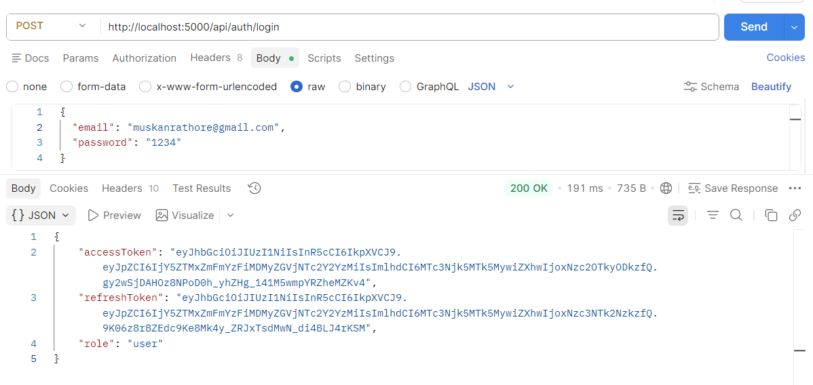
Figure 11 Postman API Testing
Overall, the test planning ensured a structured and systematic approach to testing. It helped in efficient use of time and resources while ensuring that the system meets its functional and performance requirements.

Test Result Evaluation
The evaluation of test results is important for determining the effectiveness and reliability of the system. In the VaultScan system, test results were analyzed by comparing expected outputs with actual system behavior. Each functionality was tested under different scenarios to ensure consistency and accuracy.

The evaluation process focused on identifying discrepancies such as incorrect outputs, delays, or unexpected behavior. Minor issues related to response time and formatting were identified and resolved through optimization and debugging. Critical functionalities, such as secret detection and authentication, were tested carefully to ensure correctness and stability.

The results indicate that the system performs consistently across various scenarios, including valid inputs, invalid inputs, and edge cases. The scanner successfully detects known patterns of sensitive information, and the dashboard accurately represents the findings. Authentication and API handling were also found to be reliable and secure.

Overall, the test result evaluation confirms that the system is stable, reliable, and capable of performing its intended functions effectively under normal operating conditions.

Detailed Testing Analysis
The detailed testing analysis of the VaultScan system focuses on evaluating the performance, accuracy, security, and usability of the application under different scenarios. This phase goes beyond basic testing and provides deeper insights into how the system behaves in practical conditions. Each critical component of the system was analyzed individually to ensure that it meets the expected standards of reliability and efficiency.

The analysis was carried out using real-world inputs and practical scenarios rather than controlled or simulated environments. This approach helped in understanding how the system performs when interacting with actual GitHub repositories and user actions. The evaluation included multiple runs of the same operations to verify consistency in results and to identify any irregular behavior.
Special emphasis was placed on the scanner engine, as it is the core functionality of the system. The accuracy of detection, handling of edge cases, and response time were closely observed. Additionally, system behavior under varying loads, input conditions, and user interactions was analyzed to ensure stability and robustness.

Overall, the detailed testing analysis provides a comprehensive understanding of the system’s strengths and limitations. It highlights how effectively the system performs in real-world scenarios and identifies areas for further improvement.

Accuracy Analysis of Scanner Engine
The accuracy of the scanner engine is a critical factor in determining the effectiveness of the VaultScan system. The scanner was tested using multiple GitHub repositories containing known exposed secrets such as API keys, tokens, and credentials. These test cases were used to verify whether the system correctly identifies and classifies sensitive information.

The analysis showed that the scanner is highly effective in detecting predefined patterns using regular expressions. It successfully identifies most common types of secrets and classifies them into appropriate risk levels. The addition of entropy-based analysis further improves detection by identifying high-randomness strings that may represent hidden secrets.

However, some limitations were observed during testing. A small number of false positives occurred, where non-sensitive data was incorrectly flagged as a potential secret. This is a known limitation of pattern-based detection systems. Despite this, the overall accuracy of the scanner remains reliable and useful for identifying potential vulnerabilities.

The results indicate that while the system may not achieve perfect accuracy, it provides a strong foundation for automated secret detection and significantly reduces the effort required for manual code review.

Performance Analysis
Performance analysis evaluates how efficiently the system operates under different workloads and conditions. In the VaultScan system, performance was assessed based on response time, scanning speed, database operations, and frontend responsiveness.

The system performs efficiently when handling small to medium-sized repositories, with quick response times and smooth user interaction. API requests are processed effectively, and database operations are optimized to ensure fast retrieval and storage of data. The frontend remains responsive, providing a seamless user experience during scanning and result visualization.

When dealing with larger repositories, slight delays were observed during the scanning process. This is expected due to the increased volume of data being processed. However, the system remains stable and does not crash, indicating good handling of resource-intensive operations.

Overall, the performance analysis shows that the system is capable of handling moderate workloads efficiently. While there is scope for further optimization for large-scale usage, the current performance is suitable for practical and academic applications.

Security Testing Analysis
Security testing was conducted to ensure that the system is protected against unauthorized access and potential vulnerabilities. Since the application involves user authentication and handling of sensitive information, security is a critical aspect of the testing process.
The authentication system was tested to verify that only authorized users can access protected routes. JWT-based authentication was found to be effective in securing API endpoints, and unauthorized access attempts were correctly blocked. Token validation and expiration mechanisms functioned as expected, ensuring secure session management.

Data handling was also evaluated to ensure that sensitive information is not exposed unnecessarily. The system successfully masks detected secrets before displaying them, reducing the risk of misuse. Input validation mechanisms were tested to prevent invalid or malicious inputs from affecting system behavior.

The analysis confirms that the system follows secure development practices and provides a safe environment for users. No major security vulnerabilities were identified during testing.

Usability Analysis
Usability analysis focuses on evaluating how easily users can interact with the system and perform required tasks. The VaultScan system was tested from a user perspective to ensure that the interface is intuitive and user-friendly.

The results indicate that users can easily navigate through the application and perform actions such as logging in, initiating scans, and viewing results. The dashboard provides clear and structured information, allowing users to quickly understand the security status of their repositories.
The use of visual elements such as risk levels and organized layouts improves readability and enhances the overall user experience. Minimal training is required to use the system, making it accessible to users with varying levels of technical expertise.

Overall, the usability analysis confirms that the system provides a positive user experience and effectively communicates complex information in a simple manner.

Stress and Reliability Analysis
Stress and reliability analysis evaluates how the system behaves under higher load conditions and continuous usage. The VaultScan system was tested by performing multiple scans and processing larger repositories to observe its stability and performance.

The system remained stable under moderate stress conditions, handling multiple operations without failure. No crashes or major errors were observed during testing, indicating good reliability. However, performance degradation was noticed when processing very large repositories, resulting in increased response time.

Despite this, the system continued to function correctly, and all operations were completed successfully. This indicates that the system is robust and capable of handling real-world usage scenarios within reasonable limits.

The reliability of the system is further supported by proper error handling and recovery mechanisms, which ensure that unexpected issues do not disrupt overall functionality.

Limitations Identified During Testing
During the testing process, certain limitations of the system were identified. These limitations are important for understanding the current scope of the system and for guiding future improvements.
The system relies heavily on predefined regex patterns for detecting secrets, which may not cover all possible cases. As a result, some complex or obfuscated secrets may not be detected. Additionally, the presence of false positives can affect the precision of detection, although this is a common limitation in pattern-based systems.

Performance limitations were also observed when scanning very large repositories, where processing time increases due to the volume of data. The system is also dependent on external services such as the GitHub API, which can introduce delays or restrictions.
These limitations highlight areas where future enhancements can be made to improve system accuracy, performance, and scalability.

Validation
Validation is the process of ensuring that the developed system fulfills its intended purpose and meets user expectations. While testing focuses on identifying errors and verifying functionality, validation ensures that the system actually solves the real-world problem it was designed for. In the case of VaultScan, validation was aimed at confirming whether the system effectively detects exposed secrets in GitHub repositories and provides meaningful insights to users.

The validation process was carried out using real-world scenarios and practical datasets. Public GitHub repositories were used as test inputs, including both vulnerable repositories containing exposed secrets and clean repositories without sensitive data. This approach helped in evaluating whether the system produces accurate and reliable results under realistic conditions. The outputs generated by the system were compared with expected results to ensure correctness.

Multiple validation techniques were applied to assess different aspects of the system. Output comparison was used to verify that detected secrets match expected findings. Boundary validation was performed using edge cases such as invalid repository URLs, empty repositories, and large repositories. Additionally, user-level validation was conducted to ensure that the system is easy to use and provides clear and understandable results through its dashboard.

The validation results indicate that the system successfully achieves its primary objectives. It accurately detects most known secret patterns, correctly classifies risk levels, and presents the findings in a structured and user-friendly manner. The dashboard effectively visualizes the data, allowing users to interpret results easily. The authentication system also performs reliably, ensuring secure access to the application.

Although minor limitations such as occasional false positives were observed, the overall validation confirms that the system is effective, reliable, and suitable for practical use. The validation process demonstrates that VaultScan meets both functional requirements and user expectations, making it a valuable tool for improving repository security.

Outcome of Project

The VaultScan system demonstrates effective capability in detecting exposed secrets within GitHub repositories while also presenting the findings in a structured and user-friendly manner through interactive dashboards. The system not only performs automated scanning but also transforms raw detection results into meaningful insights, enabling users to better understand the security posture of their repositories. This integration of detection and visualization ensures that the tool is not just technically efficient but also practically useful for developers and security analysts.

During implementation and testing, it was observed that the system accurately identifies various categories of sensitive information, including API keys, authentication tokens, and database connection URIs. These types of secrets are among the most commonly exposed credentials in public repositories, and their detection highlights the robustness of the pattern matching and entropy-based analysis used within the scanner. The combination of predefined signatures and intelligent detection techniques ensures high accuracy while minimizing false negatives.

Another significant outcome of the system is its ability to classify detected secrets into different risk levels such as Critical, High, Medium, and Low. This risk-based classification plays a crucial role in prioritization, allowing users to focus first on the most severe vulnerabilities that could lead to immediate exploitation. By associating each detected secret with a severity level, the system enhances decision-making and supports efficient vulnerability management.

Additionally, the dashboard-based visualization greatly improves the overall usability of the system. Instead of presenting findings as raw data, the system organizes them into clear and interactive visual formats, making it easier to interpret results at a glance. This not only enhances user experience but also supports better reporting and analysis, especially in scenarios involving large repositories with numerous findings.
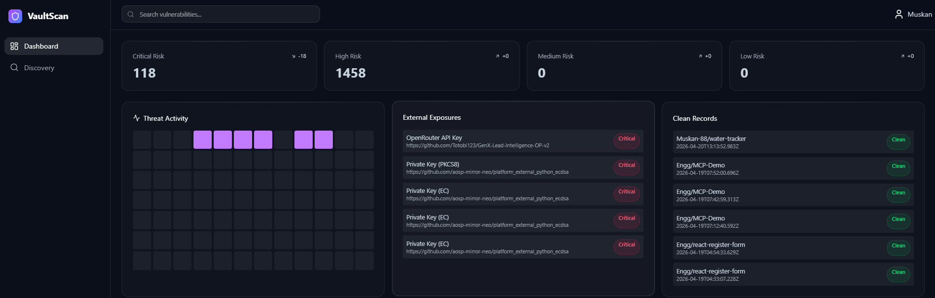
Figure 12 Dashboard Overview
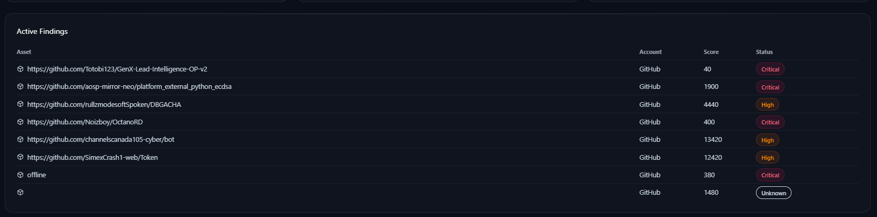
Figure 13 Active Findings Table
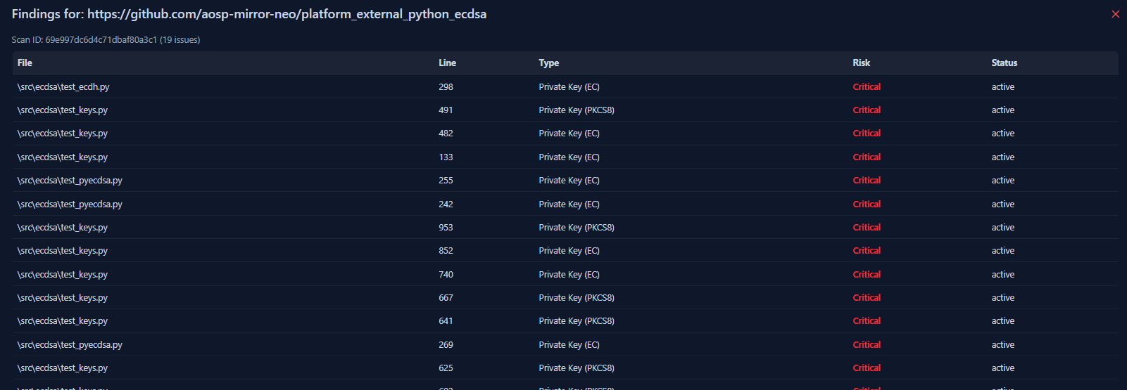

Figure 14 Threat Activity and External Exposure Panel

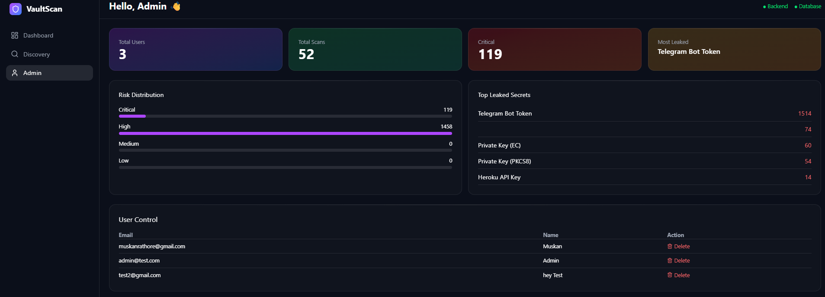
Figure 15 Admin Control Panel
The output analysis of the VaultScan system demonstrates that the generated results are both meaningful and actionable. Critical risks are clearly identified and prominently highlighted, ensuring that the most severe vulnerabilities immediately capture the user’s attention. Similarly, high-risk exposures are displayed in a structured and visible manner, allowing users to quickly assess the severity of issues present within a repository. An important observation is that repositories without any detected vulnerabilities are categorized separately as clean repositories, which helps in distinguishing secure codebases from vulnerable ones. This structured output enhances clarity and ensures that users can interpret scan results without confusion.

From the analyzed system data, it is evident that a considerable number of high-risk exposures exist across scanned repositories. The admin dashboard plays a crucial role by presenting an aggregated view of risk distribution, enabling users to understand the overall security landscape at a glance. Additionally, the system provides functionality to track scan history, which allows users to monitor improvements over time and re-evaluate previously scanned repositories. This historical tracking capability strengthens the analytical depth of the system and supports continuous security assessment.

In terms of performance, the system exhibits efficient and optimized behavior. The backend is designed to perform fast scanning through asynchronous processing and controlled concurrency, which significantly reduces the time required to analyze repositories. Database storage is handled efficiently, ensuring that findings are stored and retrieved without performance bottlenecks. Furthermore, the user interface remains responsive even when dealing with large datasets, which contributes to a smooth and seamless user experience.
The discussion of results highlights the broader significance of the system. It clearly demonstrates that automated scanning can drastically reduce the effort required for manual code reviews, which are often time-consuming and prone to human error. Early detection of sensitive information plays a vital role in preventing potential security breaches, as exposed credentials can be exploited if not addressed promptly. Moreover, the integration of visualization techniques enhances decision-making by presenting complex data in an intuitive format, allowing users to prioritize and act on vulnerabilities effectively.
The analytical insights derived from the results indicate that a substantial number of repositories contain sensitive information, emphasizing the growing need for automated security solutions. High-risk vulnerabilities are particularly common in poorly maintained or infrequently reviewed repositories, suggesting a lack of consistent security practices. It is also observed that developers often unintentionally expose credentials due to oversight or lack of awareness. The use of visualization further aids in quickly identifying patterns and trends, enabling faster and more informed decision-making.

The overall impact of the VaultScan system is significant in improving software security practices. By automatically identifying exposed secrets, the system contributes to more secure codebases and reduces the likelihood of data breaches. It also provides continuous monitoring and analytical capabilities, allowing organizations and developers to maintain better control over their repository security. This proactive approach to vulnerability detection aligns well with modern DevSecOps practices.

The system offers several advantages that enhance its practical usability. It automates the detection of sensitive information, thereby minimizing manual effort and reducing the chances of human error. Real-time analysis capabilities ensure that repositories can be scanned quickly and efficiently. Additionally, the system promotes security awareness among developers by highlighting potential risks in their code. It maintains historical records, which are useful for tracking improvements over time, and its scalable architecture allows for future enhancements and integration of advanced detection techniques. The user-friendly interface further ensures that even non-expert users can interact with the system effectively.

However, the system also has certain limitations that must be acknowledged. The detection mechanism primarily depends on predefined signatures and patterns, which may not cover all possible types of secrets. As a result, unknown or highly obfuscated patterns may go undetected. The system also requires a GitHub access token for operation, which introduces dependency on external authentication. In some cases, scanning may be limited to public repositories if access permissions are restricted, thereby reducing coverage.

During the development of VaultScan, several challenges were encountered. Handling large repositories efficiently required careful optimization to avoid performance degradation. Reducing false positives in detection was another critical challenge, as overly sensitive patterns could lead to incorrect results. Managing asynchronous API calls while maintaining system stability and performance also required thoughtful design. Additionally, ensuring secure authentication and proper handling of tokens was essential to maintain system integrity. These challenges were addressed through optimized algorithms, efficient concurrency control, and robust system architecture design, resulting in a reliable and scalable solution.

Conclusion
The VaultScan project successfully addresses a critical issue in modern software development, which is the accidental exposure of sensitive information in public repositories. With the increasing use of cloud platforms, APIs, and open-source collaboration, the risk of leaking confidential data such as API keys, authentication tokens, and database credentials has grown significantly. This project provides an effective and automated solution to detect such vulnerabilities and help developers secure their code.

The system was developed using the MERN stack, ensuring a seamless integration between the frontend, backend, and database. The use of React.js enabled the creation of a responsive and interactive user interface, while Node.js and Express.js handled backend operations efficiently. MongoDB provided a flexible and scalable database solution for storing user data, scan results, and findings.

One of the key strengths of the system is the implementation of a repository scanning engine that uses pattern-matching techniques to identify sensitive information. The classification of detected vulnerabilities into different risk levels helps users prioritize issues and take appropriate action. Additionally, the inclusion of interactive dashboards enhances data visualization, making it easier for users to understand and analyze security risks.

The project also emphasizes security through the implementation of JWT-based authentication, ensuring that only authorized users can access system functionalities. The role-based access control further enhances system security by providing separate functionalities for users and administrators.
Extensive testing and validation were conducted to ensure the reliability and performance of the system. The results indicate that the system performs efficiently under normal conditions, accurately detects most known vulnerabilities, and provides meaningful insights through its dashboard. Although minor limitations such as false positives exist, they are manageable and can be improved in future versions.

Overall, the VaultScan system demonstrates how automation can significantly improve security practices in software development. It reduces manual effort, increases detection speed, and enhances awareness among developers. The project successfully meets its objectives and proves to be a practical and scalable solution for real-world applications.

Future Scope

The VaultScan system establishes a strong foundation for detecting exposed secrets in repositories; however, there remains significant scope for future enhancement and expansion. These improvements can focus on increasing detection accuracy, optimizing performance, and extending the system to support a broader range of real-world use cases. As software security continues to evolve, incorporating advanced technologies and automation will be essential to keep the system relevant and effective.

One of the most impactful areas of improvement is the integration of Artificial Intelligence and Machine Learning techniques. Currently, the system relies heavily on predefined regex patterns, which, although effective, may not detect unknown or complex secret patterns. By introducing ML-based models trained on large datasets of code and security leaks, the system can learn contextual patterns and improve detection accuracy. This would significantly reduce false positives and enable the identification of previously unseen vulnerabilities, making the scanner more intelligent and adaptive.

Another key enhancement is the implementation of real-time scanning using GitHub webhooks. Instead of scanning repositories only on demand, the system can automatically trigger scans whenever new commits are pushed. This ensures immediate detection of exposed secrets and allows developers to address vulnerabilities at an early stage, reducing the risk of exploitation. Real-time monitoring aligns well with modern DevSecOps practices and promotes continuous security enforcement.

The system can also be extended to support multiple repository platforms such as GitLab and Bitbucket, thereby increasing its applicability across different development ecosystems. Additionally, enabling support for private repositories through secure authentication mechanisms would allow organizations to scan their internal codebases, which often contain highly sensitive information. This would significantly enhance the practical usability of the system in enterprise environments.

Performance optimization remains another critical area for future development. The scanning process can be further improved by leveraging advanced parallel processing techniques and optimizing underlying algorithms to efficiently handle large-scale repositories. This would reduce scanning time and improve scalability, ensuring that the system performs consistently even under heavy workloads.

Further enhancements can focus on improving usability and automation. The system can incorporate email and notification mechanisms to alert users whenever critical vulnerabilities are detected, ensuring timely action. Advanced reporting features, including downloadable reports in formats such as PDF or CSV, can improve documentation and sharing of results. Integration with CI/CD pipelines can enable automated security checks during development, preventing vulnerable code from being deployed. Additionally, team collaboration features can be introduced to support organizations working on shared repositories, allowing multiple users to track and manage vulnerabilities collectively.

A significant advancement would be the integration of Generative AI capabilities to provide code quality and security feedback. By analyzing detected issues, the system can suggest improvements, secure coding practices, and even recommend fixes, thereby assisting developers beyond detection. Alongside this, the system can implement automated updates to regex signatures by continuously learning from new patterns observed in public repositories, ensuring that detection rules remain up to date without manual intervention.

The use of Agentic AI represents another innovative direction, where intelligent agents can not only detect but also automatically remediate vulnerabilities. For example, the system could identify exposed secrets and either remove them, replace them with secure references (such as environment variables), or guide developers through secure resolution workflows. This shifts the system from being purely diagnostic to actively preventive and corrective.

Additional improvements include enabling background scanning processes that continuously monitor repositories without manual triggering, combined with real-time email notifications for critical findings. This ensures that users remain informed without actively interacting with the system, thereby enhancing convenience and responsiveness.

Further enhancements can include:

Email and notification systems for alerting users about critical vulnerabilities
Advanced reporting features with downloadable reports in PDF or CSV format
Integration with CI/CD pipelines to automate security checks during development
Team collaboration features for organizations working on shared repositories

From a deployment perspective, the system can be transformed into a cloud-based Software-as-a-Service (SaaS) platform, allowing users to access it without requiring local setup. Such a platform can incorporate user authentication, subscription models, and paywall integration to generate revenue while offering scalable services to individuals and organizations. A mobile application can also be introduced to provide users with on-the-go access to scan results, alerts, and analytics.

In conclusion, the future scope of VaultScan is extensive, with multiple opportunities for innovation and advancement. By integrating Artificial Intelligence, enhancing automation, expanding platform support, and adopting scalable deployment models, the system can evolve into a comprehensive and intelligent security solution tailored for modern software development environments.

Appendices

Appendix A: Sample Source Code
The appendix includes selected source code snippets of the major modules developed during the implementation of the VaultScan system. The code samples represent the authentication module, repository scanning engine, API routes, frontend components, and dashboard implementation. These samples demonstrate the practical implementation of the proposed architecture and core functionalities.

Appendix B: API Endpoints
The application exposes RESTful APIs for user authentication, repository scanning, dashboard analytics, AI-assisted security review, and administrative operations. Sample request and response screenshots generated using Postman are included for reference.

Appendix C: Database Schema
The appendix contains the MongoDB collections and schema used in the project, including Users, Scans, Findings, and Clean Records, along with sample records illustrating data organization.

Appendix D: System Screenshots
Screenshots of the developed application are included to demonstrate the graphical user interface and major functionalities, including:
- User Registration and Login
- Dashboard
- Repository Scan
- Scan Results
- AI Security Review
- Admin Dashboard

Appendix E: Project Repository
The complete source code, project documentation, configuration files, and implementation details are maintained in the project repository submitted along with this report.

References and Bibliography

[1] E. Gamma, R. Helm, R. Johnson, and J. Vlissides, Design Patterns: Elements of Reusable Object-Oriented Software. Addison-Wesley, 1994.

[2] I. Sommerville, Software Engineering, 10th ed. Pearson Education, 2016.

[3] R. S. Pressman and B. R. Maxim, Software Engineering: A Practitioner's Approach, 9th ed. McGraw-Hill Education, 2019.

[4] MongoDB Inc., "MongoDB Documentation." Available: https://www.mongodb.com/docs/

[5] React Team, "React Documentation." Available: https://react.dev/

[6] Node.js Foundation, "Node.js Documentation." Available: https://nodejs.org/docs/

[7] Express.js, "Express Documentation." Available: https://expressjs.com/

[8] GitHub, "GitHub REST API Documentation." Available: https://docs.github.com/en/rest

[9] C. E. Shannon, "A Mathematical Theory of Communication," Bell System Technical Journal, vol. 27, no. 3, pp. 379–423, 1948.

[10] OWASP Foundation, "OWASP Top Ten." Available: https://owasp.org/www-project-top-ten/

[11] Groq Inc., "Groq API Documentation." Available: https://console.groq.com/docs

